Table of Contents

Project Charter – law firm brp team 3

objectives 3

Success Criteria 3

Roles and responsibilities 3

Consent & Signatures 4

Project Scope – Law Firm brp team 5

Description 5

Purpose 5

Success Criteria 5

Assumptions 5

Constraints 6

Project Deliverables 6

Project ConStraints 6

Liability 7

Consent & Signatures 7

Gantt Chart 10

IS187: Billing System Questionnaire 11

Survey design outline 13

IS 187: IS Practicum 16

CAPSTONE PROJECTS: 16

SEVEN ISSUES OF EVALUATION for THE LAW OFFICE OF MUGRIDGE 16

Law Firm BPR 18

Survey on Business Process 18

Survey Results 20

Database Architecture 24

Data Dictionary 26

Entity Relationship Overview: 28

IS187: IS Practicum 29

Progress Report #_1 29

IS187: IS Practicum 31

Progress Report #_2 31

IS187: IS Practicum 33

Progress Report #_3 33

IS187: IS Practicum 36

Progress Report #_4 36

IS187: IS Practicum 38

Progress Report #_5 38

***Milestone Report 1*** 40

**Back End Design:** 41

**Database:** 43

Database Scripts: 45

**GUI Design:** 55

Screenshots of Application: 56

Future Development: 58

Milestone Report 2 61

Back End Design: 62

GUI Design: 69

User Manual 74

# Project Charter – law firm brp team

|  |  |
| --- | --- |
| Project Title: | Billing System Program |
| Authors of Scope: | Colin Kay, Albert Badalyan, Pagoda Pang, Kaleb Martens |
| Date: | September 9, 2012 |

## objectives

The goal of this project is to develop a centralized billing platform for the Law Office of David R. Mugride. To do so, a software solution will be developed with a database and simplified graphic user interface (GUI). The software solution should reduce, or possibly eliminate the need for a manual billing process and any discrepancies caused by dispersed billing processes.

## Success Criteria

|  |  |  |
| --- | --- | --- |
| Business Value | Criteria for Project Success | Measurement |
| Efficient way to bill | Users can efficiently bill for services rendered. | Software functionality to record various aspects for billing |
| Accurately monitor compensation and expenses | Users can monitor and measure appropriated funds, fees, and expenses | Software functionality to display details on services provided |
| Eliminating multiple forms for billing | Users can perform billing tasks in a centralized platform | Software functionality to record, display, and render reports for billing |

## Roles and responsibilities

|  |  |  |
| --- | --- | --- |
| Name | Position | Responsibility |
| Dr. Ojoung Kwon | Instructor | Monitor the project and team and provide external resources |
| James Mugridge | Sponsor | Monitor the project and provide the team with information required for the project |
| Tim Bartell | Sponsor | Monitor the project and provide the team with information required for the project |
| Colin Kay | Project Manager | Manage project; provide team with structure and support system |
| Albert Badalyan | Database Administrator | Develop a relational database and manage functionality |
| Pagoda Pang | Documenter/Technical Writer | Document project details and technical features/functionality |
| Kaleb Martens | GUI Developer | Develop/design GUI |

### Consent & Signatures

Dr. Ojoung Kwon, Instructor Date

James Mugridge, Project Sponsor Date

Tim Bartell, Project Sponsor Date

Colin Kay, Project Manager Date

Albert Badalyan, Database Administrator Date

Pagoda Pang, Documenter/Technical Writer Date

Kaleb Martens, GUI Developer Date

# Project Scope – Law Firm brp team

|  |  |
| --- | --- |
| Project Title: | Billing System Program |
| Authors of Scope: | Colin Kay, Albert Badalyan, Pagoda Pang, Kaleb Martens |
| Date: | September 9, 2012 |

## Description

The Law Offices of David R. Mugridge is a small firm located in downtown Fresno, California that specializes in criminal defense. They have been representing men and women in criminal defense and appeals throughout the Central Valley in English and Spanish. The Law Offices of David R. Mugridge is also licensed to practice in all state courts and federal district courts in California, in the U.S. Circuit Court for the 9th Circuit, and in the United States Supreme Court. Our sponsors from the law office will include James Mugridge and Tim Bartell.

## Purpose

The purpose of this project is to develop a software based billing system for the Law Offices of David R. Mugridge. The current billing system is dispersed throughout the firm. Billing submittals are often completed in various forms and formats, including Microsoft Excel, by individual clerks and attorneys.

To reduce the potential for conflicts associated with a manual billing process, a software solution will be developed which centralizes the billing system, standardizes forms, and generates specified reports. To construct the billing system software, a bottom-up approach will be utilized.

## Success Criteria

The criteria for success or failure will be based upon our sponsors expectations, project terms and conditions, and completion of deliverables that are agreed upon herein.

## Assumptions

In order to successfully complete our project, the team will operate under the assumption that the following resources will be available during the normal course of work:

* Internet Access
* BlackBoard / Discussion Board / Collaboration Tools
* GitHub
* Microsoft Visual Studio 2012
* Microsoft Project
* Microsoft Office
* Microsoft SQL Server Express 2008 with Advanced Services
* Electronic Mail Access
* Access to Subject Matter Experts (Dr. Kwon, James Mudgride, and Tim Bartell)

## Constraints

A primary constraint for this project will be the amount of time team members are able to devote. As such, team members will devote a reasonable amount of time that is appropriate for a 3-unit course. Also, team member’s posses limited knowledge in regards to the billing processes of a criminal defense law firm. There is a wide-range of concepts, terms, and processes which must be understood before the billing system software can be developed.

Another constraint is the team member’s limited experience with the new software development tools used for this project. Although team member’s posses a strong understanding of the application development process, and have developed software solution in the past; the newer tools that will be used throughout this project could present minor challenges.

## Project Deliverables

|  |  |
| --- | --- |
| Documentation | Written documentation regarding user requirements |
| Data Dictionary |
| Data Flow Diagram (DFD) |
| Entity-Relationship Diagram (ERD) |
| Documentation related to functionality of various components |
| Application/GUI | GUI |
| Time-recording capability |
| Reporting capability |
| Client management capability |
| User management capability |
| Database | Database Design |
| Microsoft SQL Server 2008 Express with Advanced Services |
| Relation database with necessary entities and attributes, relationships, views, and stored procedures |
| Reporting Services | “Application and Order for Payment of Court Appointed Vendor: PGN-90 E05-11” Report developed in SQL Server Business Intelligence Development Studio |
| Reporting Services feature that is part of SQL Server 2008 Express |

## Project ConStraints

The team doesn't have much experience on how the attorney’s records/tracks their data. It will take some time understanding it all. The limitation on what framework to use to build this system on is another constraint. We do not have a lot of coding experience building an application from the ground up. The class course is only three months, the application might not be bug free or fully tested by then.

## Liability

The billing system program project for the Law Offices of David R. Mugridge described herein is for educational purposes only. It is understood that the project is done solely for completing the requirements of the Information Systems (IS) 187 under the direction of Dr. Ojoung Kwon.

The project team, it’s individual members, Dr. Ojoung Kwon, the IS/DS Department of the Craig School of Business, and California State University, Fresno are not liable under any ramifications of the law by signing this scope, and will not be held liable or responsible for any legal issues that may arise in the course of utilizing any aspect of this project.

All project components, including but not limited to deliverables, code, and reports, shall become property of the Law Office of David R. Mugridge upon the completion of the project at the end of the Fall 2012 semester.

This project is for educational use and it is understood that this project fulfills the requirements of completing the IS 187 course. There is no guarantee that the final product will not have glitches, flaws, or contained system errors once the semester has ended.

### Consent & Signatures

Dr. Ojoung Kwon, Instructor Date

James Mugridge, Project Sponsor Date

Tim Bartell, Project Sponsor Date

Colin Kay, Project Manager Date

Albert Badalyan, Database Administrator Date

Pagoda Pang, Documenter/Technical Writer Date

Kaleb Martens, GUI Developer Date

## Gantt Chart

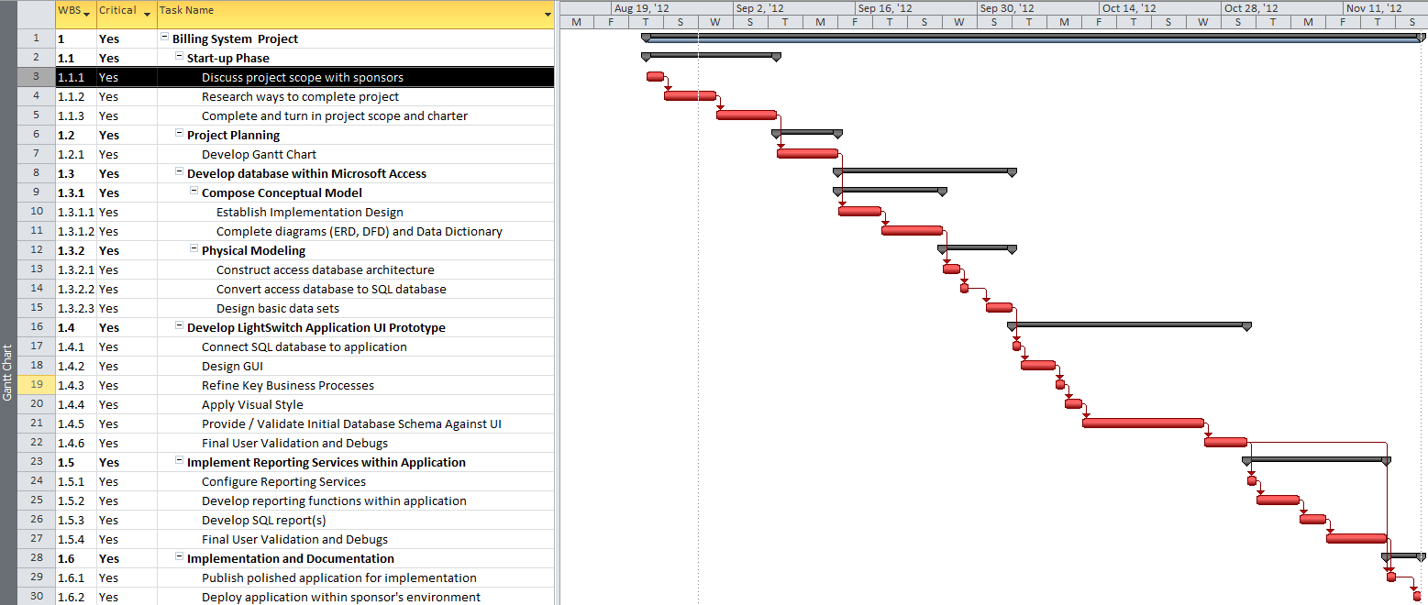

**Team Law Firm BPR**

**IS 187**

**Team Members:**

**Albert Badalyan**

**Colin Kay**

**Kaleb Martens**

**Pagoda Pang**

## IS187: Billing System Questionnaire

**Understanding the problem of the sponsor**

Q: What are you guys looking for?

A: A way to track information for court cases

Q: Can you describe how these cases work?

A: Each case has a certain number funds that are allowed for it, we are allowed to work until the funds have been exhausted from that case.

Q: In the past how has your current method of recording/tracking these cases have been?

A: Not too good, we often work over our funds and don't get paid at the end. So we end up working for free.

Q: How are you guys currently recording/tracking the information?

A: Some by paper and some of the information are on excel sheets and word documents. It's distributed throughout our office.

Q: Why do you guys need this system for? Isn't it better just making regulations and standards in the office to control how much work has been done on each case?

A: It's too hectic; we have about three to four attorneys. Each working on a different case sometimes we forget to even record what we do, because we get sidetrack from all the readings we do.

**Understanding the needs of the sponsor**

Q: Besides the attorneys who else will be using it?

A: We have law clerks, and a sectary that helps us do some paper work. They would need to use it as well.

Q: Are the attorneys the only one working on the cases?

A: Sometimes we hire a specialist to do some work.

Q: Are there rates on which you guys set?

A: Yes, the rates are static and charged per hour. They are listed on the sheets we gave you guys.

Q: Are there reoccurring clients?

A: Yes, sometimes there are

Q: How are cases categorized as?

A: There are four types; we have a sheet that describes them all.

Q: Are there expenses that need to be recorded as well?

A: There are a couple such as, travel, photocopying, mileage, and a couple of others. They are listed on the sheet as well.

**Getting an idea on how to design the application**

Q: Does this application need to be user friendly?

A: We would like to, however if it just works and looks ugly we wouldn’t mind

Q: So you guys need a system that will record what you have done and it will calculate the remaining funds correct?

A: Yea something like that we have a forum that needs to be filled out at the end of the case. If you guys can somehow take all the values and place them on there, that would be great.

Q: This forum is the most important one out of the rest?

A: Yes it’s what the court uses, we have other forums to fill out but if you guys can just get that one. That would be the one we would want the most

Q: Ok, so there would be multiple users correct?

A: Yes

Q: How many computers do you guys currently have?

A: About four computers

Q: Is it possible to use one of the computers as a SQL server

A: That would be fine with us; we’re willingly to invest into some equipment if the application needs it

Q: How would you like time to be tracked and recorded?

A: We were thinking of it automatically starting, once we press a button time would track itself. Say we push a button to start, and then push it again to stop it.

Q: Do you mind if you have to manually enter in time?

A: Not at all, any system that is currently better than ours would help us.

Q: Are you guys all using Windows 7?

A: One of us has a Mac, and the rest are running Windows 7 or has a Windows operating system.

**Team Law Firm BPR**

**IS 187**

**Team Members:**

**Albert Badalyan**

**Colin Kay**

**Kaleb Martens**

**Pagoda Pang**

## Survey design outline

**Introduction**

To further get a grasp on how to design the system for the Mugridge attorneys, the team has created a survey to better understand their day to day process. The survey contains a mixture of rated questions and open ended questions for the users to fill out. After all the users have taken the survey it will later be analyze for information. This survey is anonymous and confidential none of the results will be pass out to anyone else besides to the team and Dr. Ojoung Kwon's IS187 class.

**Design Process**

The survey is used to get a better understanding of how the attorneys function with their current system. Most of the survey questions are geared toward their current business process. This will give us an idea on how they are currently functioning. Understanding their existing process helps us focus on areas in our project.

**Survey Mission**

The survey is used to get feedback from the attorneys so we can better design our system for them. The survey is mainly use to get more insight on how things are done currently. We would like to get an idea of what the attorney's think about their current system.

**Goals of the Survey**

Goal 1: Finding how important automation is toward the business.

This goal is set on Questions 1, 2, 3, and 4.

Goal 2: Finding out problems and methods they would change in their current system.

This goal is implemented on questions 6, 7 and 10 within the survey.

Goal 3: Figuring out the most important aspect of their business process.

This goal is set on question 9 on the survey

Question 1:

This question has a rating on it, 1 being the lowest and 5 being the highest. The question pertains on satisfaction level on the current workflow on things.

Question 2:

Like question 1 this is also a rated question. This question focuses on importance of automation of expenses in an application.

Question 3:

This is another rating question, this time it is about the importance of technology in their day to day business. Like the rest of the rating question it is scaled 1-5, 1 being the lowest and 5 being the highest.

Question 4:

This question was designed to see how important automation is for company growth. This is another rated question like the previous ones.

Question 5:

Like the above questions this one is a rated one as well. This question pertains to the technical skills of the end users. It uses a scale of 1-5, 1 being the lowest and 5 being the highest.

Question 6:

This is an open ended question; the end user can in put their thoughts and consideration on the matter. The question is seeking what would the end user change about the business process they are currently using.

Question 7:

Another open ended question, due to the complexity of the question user input is required. This question focuses on the issues/flaws/hindrances of the present business process. It requires the user to think about what actually stops the progression of work.

Question 8:

Question 8, is an open ended question it requires user thought and their creativity. This question engages the user to think of was to enhance a certain business process

Question 9:

Similar to question 7, this question asks about the vital points of their day to day process. It asks what areas are critical in the work flow, and if there are any alternatives to it.

Question 10:

The last of the open ended question, this one is mainly about what could be avoided if an enhanced business process was implemented. This question allows the user to input all the problems they have encountered while working.

**Conclusion**

The goal of the survey is to gain more insight of the day to day process of the attorneys. Getting more knowledge on this will allow us to design the system better.

The survey will be conducted by using Survey Monkey, an online service. Using this service will allow maximum anonymity. Everything will be confidential; all results will remain with the team to analyze.

**Team Law Firm BPR**

**Team members:**

**Albert Badalyan**

**Colin Kay**

**Kaleb Martens**

**Pagoda Pang**

## IS 187: IS Practicum

## CAPSTONE PROJECTS:

## SEVEN ISSUES OF EVALUATION for THE LAW OFFICE OF MUGRIDGE

1. The current management style of the Law Office of David R. Mugridge is a consultative approach. The managers, or in the case of Mugridge Law Office, attorneys, make all of the final decisions but encourage feedback from their employees. Communication is downward in this sense. The organization is comprised of a couple attorneys, a few clerks, and a couple of secretaries. In this regard there isn’t much feedback to be given to an alternative approach of organization structure or management style as the company needs to retain the hierarchy that’s put in place to maintain a higher level efficiency and thoroughness.
2. The current structure of their information systems is chaotic. They lack the following: a protected centralized location for their data, minimal recovery plan in case of theft/hazards, inefficient workflow between the different levels of the company. The time tracking program that is being delivered is only touching on a small portion of what is needed to bring the company up to an acceptable present technological workplace. Besides the addition of the time tracking package, we suggest to put in place best practices for data storage and data backup.
3. The current accounting system lacks a uniform procedure of billing out to clients. The firm has two types of clients they handle, ones issued to them by the state and walk in clients. Our program handles the clients issued by the state by creating a PNG-90 report that allows the firm to be reimbursed by the court. What they lack though is how to track billing to their walk in clients. In order to keep a uniform record, they will need to implement either a separate program to track the actual invoices they receive, or expand on our application to include that feature.
4. Their financial planning system is the main focus of what our project is attempting to resolve. It is clear that it lacks a coherent view of the current transactions of the company. The biggest problem they now face is working over budget and not properly allocating their time. Our suggestion is to make everyone in the company adopt our program and centralize the data so that everyone views the same data. If everyone uses best practice it will eliminate costly unpaid overtime and help future budgeting.
5. The current legal framework and contractual systems are high standards for the Mugridge Law Firm. Their current strengths focus on the ability to conform to the court standards and be able to complete cases with the proper submission of forms. In order to lessen the possibilities of inaccurate submitted forms to the court, we suggest to automate the report generation process so that it will eliminate human error.
6. The current operations protocol relates to their current information system structure and financial planning system. The workflow between the secretaries, clerks and attorneys doesn’t follow a set structure and lacks the efficiency of a modern technological environment. By automating most of the current process in the form of reports and logging, they can minimize the time spent doing clerical work and more on projects that bring in revenue.
7. Mugridge Law Firm’s current competitor tracking methods resort to their employees monitoring the competing firms websites. While this will give them a view of their competition from a marketing standpoint, it doesn’t give them insight to best practices used within the firm. We suggest in order to increase efficiency, to attend seminars and possible outside consulting to see the areas where they are weakest

## Law Firm BPR

## Survey on Business Process

**Introduction**:

This is the survey we designed for our sponsors to take. It consists of very basic questions to get an idea of how they currently operate in the office. It will also give us insight on problems they have with the existing business process. The survey is anonymous and confidential; all results will be saved for our personal research.

**Questions:**

1. Rate your satisfaction on a scale of 1-5, 1 being low, 5 being high, the current workflow of the business in terms of the beginning of a project to the end.

1 2 3 4 5

2. On a scale of 1-5, 1 being low, 5 being high, how automated do you want the expense keeping capabilities of an application.

1 2 3 4 5

3. On a scale of 1-5, 1 being low, 5 being high, how much of an impact does technology have in your day to day business.

1 2 3 4 5

4. On a scale of 1-5, 1 being low, 5 being high, how important is it to the company growth for an automated process.

1 2 3 4 5

5. On a scale of 1-5, 1 being low, 5 being high, how confident in terms of technical skill with a computer are you?

1 2 3 4 5

6. What are some thing you would change in current business practices?  
  
  
7. What are some issues/flaws/hindrances in the current business processes?

8. If possible, how would you enhance the various business processes? I.e., would you incorporate technology to centralize certain aspects?

9. What are the primary areas within current business processes that require the most attention? Are alternative methods for performing the same processes available?  
  
  
10. Can you describe a problem that was encountered that could have been avoided with enhanced business processes? (Please identify the key element to preventing the problem including: need for technology, better staff training, or enhanced policies and procedures)?

**Team Law Firm BPR**

**Team members:**

**Albert Badalyan**

**Colin Kay**

**Kaleb Martens**

**Pagoda Pang**

## Survey Results

The main goal of the survey was to get more insight on the day to day process of the attorneys. Knowing their usual routine helps us design the system better. We used Survey Monkey, an online service, to distribute out the survey. The use of Survey Monkey, allowed us to send out the survey in a convenient way, so every worker in the office could take it. We wanted as many workers to take it, so our analysis of the inputs would be significant.

Unfortunately when the results came back, there were only two surveys that were completed. This makes our rating analysis skewed. Data from the rating questions won’t be vital to use due to lack of surveys completed. However the input from the open ended questions, gave us some useful information.

**Results**

Question 6:

This question asks the user for input on what they would change in the work office. The question was “What are some thing you would change in current business practices?”

**Responses:**

“I would have a simple program that tracks billing so that we would stop losing money because of a failure to build.”

“More efficient billing system, streamlined billing system, less paper and more electronic data storage.”

**Analysis:**

From the responses we can infer, the users want a more automated process. They need something easy to use for their purpose.

Question 7:

Respondents were given another opportunity to give a written statement on issues they had. This is verbatim of what was asked “What are some issues/flaws/hindrances in the current business processes?”

**Responses:**

“There are too many links in the chain in terms of our billing process. If we had a single, centrally accessible program we would not have as many problems with billing.”

“There is a billing flaw, in that clerks submit bills to the attorney, who then has a hard time getting those bills to the billing clerk who then subsequently fills out the billing sheets.”

**Analysis:**

According to the responses, there are many processes that occur when conducting the bill. During the process there seems to be many mistakes that happen. Streamlining the process is what the users are looking for.

Question 8:

Next we wanted to focus on what direction the employees wanted to take their company in terms of the technology backbone they would be on. We asked, “If possible, how would you enhance the various business processes? I.e., would you incorporate technology to centralize certain aspects?”

**Responses:**

“Right now I am primarily concerned about the billing process but if we had a program that was complete workflow and had automated reminders for billing dates and to-do lists for individual workers we would keep a lot better track of the office business.”

“We are looking to incorporate technology to all aspects of our business process. We are looking to have a fully electronic billing system on the file server, go paperless, and incorporate the usage of ipads/tablets/computers in the courtroom to enhance the jury experience.”

**Analysis:**

It seems that the billing process takes quite a bit of work to do. The need for automation is expressed within both statements.

Question 9:

In this next question we wanted to know what their critical processes were and if they were currently handling these processes through other means. We analyzed this by asking them, “What are the primary areas within current business processes that require the most attention? Are alternative methods for performing the same processes available?

**Responses:**

“Billing and Organization.”

“The attorneys are typically in court, the clerks typically are in the office researching/writing and the secretary/interns are answering phones and filing documents. There doesn't seem to be alternative processes available for this, but an enhanced billing system would help us keep track, in a centralized location on the server, of all the hours we can bill for.”

**Analysis:**

While the first response doesn't tell us much, the second statement gives a lot of detail. It tells us there's a separation of work between attorney's and clerks. Nothing is unified; things are disconnected from one another.

Question 10:

Next we asked them directly how they would solve some of their problems. We wondered if building an application a certain way would truly accomplish what they needed. We asked, “Can you describe a problem that was encountered that could have been avoided with enhanced business processes? (Please identify the key element to preventing the problem including: need for technology, better staff training, or enhanced policies and procedures)?”

**Responses:**

“Bills were placed in the inbox to be paid to associates and were thereafter never transferred to be billed to the client so Mr. Mugridge paid out money that was never billed to the client.”

“Our billing clerk has problems converting everyone's billed hours into the court approved form, of which we must submit to the court to be paid. Thus, if a system could be produced that would more easily track everyone's hours, all she would have to do is fill in blanks, or in the best scenario, click a print button and submit the required form to the court.”

**Analysis:**

From these statements, there seems to be a huge problem with the current business process. For one bills aren't going to the clients, and thus causes the clerks and attorneys to not get paid at all. Essentially they are working for free if bills do not reach clients at all.

**Conclusion**

Based off the analysis, there are some things we can conclude. First off, the work flows of things are disconnected from one another. One worker does a task and things are left incomplete, another worker does some work on the same task but isn’t connected to the original. This causes a disjoined workflow. Things are scattered across the office, and when it comes time to produce a bill, it is hard to get all the correct information and process the bill due to this very nature.

Second there is a concern for consolidating paper work. The users want things to be automated. A system where it can keep a record of what has been done, and how much funds are left. In order to accomplish this we need to design a process where multiple users can input at one time and it be updated on the fly. That will give the clients an accurate reading of the total funds. Along with this will be the reporting feature which will be implanted directly in the system. This will reduce the paper footprint left behind with the current process.

## Database Architecture

|  |
| --- |
| RELATIONSHIPS |
| MANY employees TO MANY cases  ONE client TO MANY cases  MANY specialists TO MANY cases  MANY cases TO MANY expenses |

|  |
| --- |
| ENTITIES |
| CLIENTS, EMPLOYEES, CASE, SPECIALISTS, CASE_EMPLOYEE, CASE_SPECIALIST, CASE_EXPENSES  LOOKUPS:  CLIENT_STATUS  CLIENT_SUFFIX  EMPLOYEE_TYPE  CASE_TYPE  SPECIALIST_TYPE  EXPENSE_TYPES |

|  |
| --- |
| DBDL  **CLIENTS**(CLIENT_ID, CLIENT_STATUS_ID, APP_RET_DATE , CLIENT_PREFIX_ID, FIRST_NAME, LAST_NAME, DOB, STREET_ADDRESS, CITY, STATE, ZIP, PHONE, JID_CDC, SSN, DRIVER_LICENSE, EMAIL )  PK CLIENT_ID  FK CLIENT_STATUS_ID 🡺 CLIENT_STATUS  FK CLIENT_PREFIX_ID 🡺 CLIENT_SUFFIX  **CLIENT_STATUS**(CLIENT_STATUS_ID, CLIENT_STATUS)  PK CLIENT_STATUS_ID  **CLIENT_SUFFIX**(CLIENT_SUFFIX_ID, CLIENT_PREFIX)  PK CLIENT_PREFIX_ID  **EMPLOYEES**(EMPLOYEE_ID, EMPLOYEE_TYPE_ID, FIRST_NAME, LAST_NAME, DOB, STREET_ADDRESS, CITY, STATE, ZIP, PHONE, EMAIL)  PK EMPLOYEE_ID  FK EMPLOYEE_TYPE_ID 🡺 EMPLOYEE_TYPE  **EMPLOYEE_TYPE**(EMPLOYEE_TYPE_ID, EMPLOYEE_TYPE)  PK EMPLOYEE_TYPE_ID  **COURT_CASE**(CASE_ID, CASE_NUMBER, CASE_CATEGORY_ID, CLIENT_ID, CASE_TITLE, CASE_DATE, CLIENT_RELATIONSHIP, NOTES)  PK CASE_ID  FK CASE_CATEGORY_ID 🡺 CASE_CATEGORIES  FK CLIENT_ID 🡺 CLIENTS  **CASE_TYPE**(CASE_CATEGORY_ID, TITLE, AMOUNT)  PK CASE_CATEGORY_ID  **SPECIALISTS**(SPECIALIST_ID, FIRST_NAME, LAST_NAME, PHONE, EMAIL, STREET_ADDRESS, CITY, STATE, ZIP SPECIALIST_TYPE_ID)  PK SPECIALIST_ID  FK SPECIALIST_TYPE_ID 🡺 SPECIALIST_TYPE  **SPECIALIST_TYPE**(SPECIALIST_TYPE_ID, SPECIALIST_TYPE)  PK SPECIALIST_TYPE_ID  **EXPENSE_TYPES**(EXPENSE_TYPE_ID, EXPENSE_TYPE)  PK EXPENSE_TYPE_ID  **CASE_EMPLOYEE**(CASE_ID, EMPLOYEE_ID, EMPLOYEE _RATE, START_TIME, END_TIME, EMPLOYEE_FIXED_COST)  PK CASE_ID  PK EMPLOYEE_ID  **CASE_SPECIALIST**(CASE_ID, SPECIALIST_ID, SPECIALIST_RATE, HOURS, SPECIALIST_FIXED_COST)  PK CASE_ID  PK SPECIALIST_ID  **CASE_EXPENSES**(CASE_ID, EXPENSE_TYPE_ID, EXPENSE_COST)  PK CASE_ID  PK EXPENSE_TYPE_ID |

­

## Data Dictionary

|  |  |  |  |  |
| --- | --- | --- | --- | --- |
| **Table** | **Attribute** | **Type** | **Key** | **Description** |
| **Case_Employee** | Case_Emp_ID | Int | Primary | Case Employee ID |
|  | Case_ID | Int | Foreign | Case ID |
|  | Employee_ID | Int | Foreign | Employee ID |
|  | Employee_rate | Money |  | Employee Rate |
|  | Description | NVarChar (255) |  | Description |
|  | Start_Time | DateTime |  | Start Time |
|  | End_Time | DateTime |  | End Time |
|  | Hours_Worked | Decimal (5,2) |  | Hours worked on case |
|  | Employee_Fixed_Cost | Money |  | Employee fixed cost |
|  | Calc_Time | Decimal (5,2) |  | Calculated Time |
|  | Total_Time | Decimal (5,2) |  | Total Time |
|  | E_Miles | Int |  | Employee miles |
| **Case_Expense** | Case_Exp_ID | Int | Primary | Case Expense ID |
|  | Case_ID | Int | Foreign | Case ID |
|  | Description | NVarChar (255) |  | Description |
|  | Expense_Cost | Money |  | Expense Cost |
|  | Date | Date |  | Date |
| **Case_Specialist** | Case_Spec_ID | Int | Primary | Case Specialist ID |
|  | Case_ID | Int | Foreign | Case ID |
|  | Specialist_ID | Int | Foreign | Specialist ID |
|  | Specialist_Rate | Money |  | Specialist Hourly Rate |
|  | Hours | Int |  | Hours worked |
|  | Specialist_Fixed_Cost | Money |  | Specialist Fixed Cost |
|  | S_Miles | Int |  | Miles Driven |
|  | S_Date | Date |  | Date |
| **Case_Type** | Case_Category_ID | Int | Primary | Case Category ID |
|  | Case_Catagory | NVarChar (255) |  | Case Category |
|  | Title | NVarChar (255) |  | Title of Case Category |
|  | Amount | Money |  | Amount in Case Category |
| **Client_Status** | Client_Status_ID | Int | Primary | Client Status ID |
|  | Client_Status | NVarChar (25) |  | Client Status |
| **Client_Suffix** | Client_Suffix_ID | Int | Primary | Client Suffix ID |
|  | Client_Suffix | NVarChar (25) |  | Client Suffix |
| **Clients** | Client_ID | Int | Primary | Client ID |
|  | Client_Status_ID | Int | Foreign | Client Status ID |
|  | App_Ret_Date | DateTime |  | Application Retention Date |
|  | Client_Suffix_ID | Int | Foreign | Client Suffix ID |
|  | First_Name | NVarChar (255) |  | First Name |
|  | Last_Name | NVarChar (255) |  | Last Name |
|  | DOB | DateTime |  | Date of Birth |
|  | Street_Address | NVarChar (255) |  | Street Address |
|  | City | VarChar (100) |  | City |
|  | State | Char (2) |  | State |
|  | Zip | Int |  | Zip |
|  | JID_CDC | NVarChar (100) |  | JID CDC |
|  | SSN | Int |  | Social Security Number |
|  | Driver_License | NVarChar (25) |  | Driver License |
|  | Email | NVarChar (50) |  | Email address |
|  | Phone | NVarChar (20) |  | Phone number |
| **Court_Case** | Case_ID | Int | Primary | Case ID |
|  | Case_Number | VarChar (255) |  | Case Number |
|  | Case_Category_ID | Int | Foreign | Case Category ID |
|  | Client_ID | Int | Foreign | Client ID |
|  | Case_Type | NVarChar (255) |  | Case Type |
|  | Case_Title | NVarChar (255) |  | Title of Case |
|  | Case_Date | DateTime |  | Date case was appointed |
|  | Client_Relationship | NVarChar (255) |  | Client relationship |
|  | Notes | NVarChar (255) |  | Additional Notes |
| **Employee_Type** | Employee_Type_ID | Int | Primary | Employee Type ID |
|  | Employee_Type | NVarChar (255) |  | Employee Types |
| **Employees** | Employee_ID | Int | Primary | Employee ID |
|  | Employee_Type_ID | Int | Foreign | Employee Type ID |
|  | First_Name | NVarChar (255) |  | First Name |
|  | Last_Name | NVarChar (255) |  | Last Name |
|  | DOB | DateTime |  | Date of Birth |
|  | Street_Address | NVarChar (255) |  | Street Address |
|  | City | VarChar (100) |  | City |
|  | State | Char (2) |  | State |
|  | Zip | Int |  | Zip |
|  | Email | NVarChar (50) |  | Email address |
|  | Phone | NVarChar (20) |  | Phone Number |
| **Specialist_Type** | Specialist_Type_ID | Int | Primary | Specialist Type ID |
|  | Specialist_Type | NVarChar (255) |  | Specialist Type |
| **Specialists** | Specialist_ID | Int | Primary | Specialist ID |
|  | Specialist_Type_ID | Int | Foreign | Specialist Type ID |
|  | First_Name | NVarChar (255) |  | First Name |
|  | Last_Name | NVarChar (255) |  | Last Name |
|  | DOB | DateTime |  | Date of Birth |
|  | Street_Address | NVarChar (255) |  | Street Address |
|  | City | VarChar (100) |  | City |
|  | State | Char (2) |  | State |
|  | Zip | Int |  | Zip |
|  | Email | NVarChar (50) |  | Email address |
|  | Phone | NVarChar (20) |  | Phone number |

## Entity Relationship Overview:

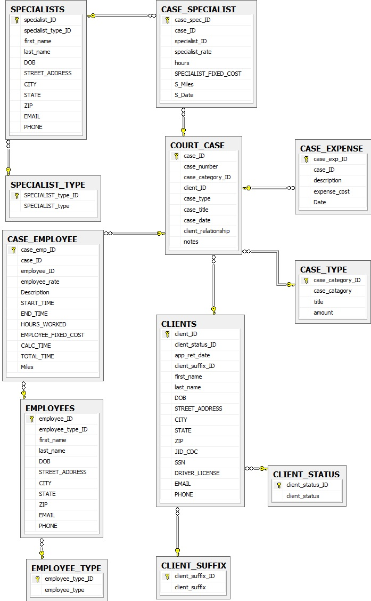

## IS187: IS Practicum

## Progress Report #_1

|  |  |
| --- | --- |
| **Project Name: Law Firm Billing System** | |
| **Reported by: Pagoda Pang** | **Date:9/27/12** |
| **Report Period: From 8/27/12 To 9/27/12** | |
| **Team Members: Albert Badalyan, Colin Kay, Kaleb Martens, Pagoda Pang** | |
| **Project Description: This project is built using Visual Basic Lightswitch, with a SQL back end. The program is intended to help keep track of how many hours and funds have been spent within a case.**  **Progress Summary:**   1. Work completed as planned   We finished outlining, what is needed to be represented in the system. A lot of the structuring the database has been done. We sat down a couple of times discussing the relationships between the tables created.   1. Work planned but not completed   The plan is to continue working on it throughout the remaining weeks. Once we have a good prototype, we plan on calling the attorneys to test run and get feedback from them.   1. Work-in-progress   We are currently looking for tables we have missed to include in the database. We are also designing how the workflow of the application should be. Such as deciding what should show up on each screen of the application. If there are going to be multiple screens for doing a task or how data should be entered.   1. Work to be done next period   There is still a number things to work on, we are going to figure out a way to display calculated fields. The report is another thing we have to work on, once we get the calculated fields figured out, the report is next to be worked on. | |
|  | |
| **Problems Encountered:**  **We ran into some fields missing within the data base, there isn't a way were time can be tracked within the data base. We will continue looking for missing fields and attributes so the program can be accurate. There is also the issue of how to calculate values during the report, but we will continue to work on it.** | |
| **Overall Assessment:**  **The project is going at a good pace; nothing seems to be holding us up yet.** | |

Validated by Team Leader: ________________________________ Date: ______________________

## IS187: IS Practicum

## Progress Report #_2

|  |  |
| --- | --- |
| **Project Name: Law Firm Billing System** | |
| **Reported by: Pagoda Pang** | **Date:9/25/12** |
| **Report Period: From 9/27/12 To 10/15/12** | |
| **Team Members: Albert Badalyan, Colin Kay, Kaleb Martens, Pagoda Pang** | |
| **Project Description: This project is built using Visual Basic Lightswitch, with a SQL back end. The program is intended to help keep track of how many hours and funds have been spent within a case.**  **Progress Summary:**   1. Work completed as planned   Current testing of the system still indicates, problem with the database. We went back to fix up the database schema. For now the database seems to be working as intended. There is still elbow room to work with. The next few days, it'll start to shrink down making the database more concise as we run it through tests.   1. Work planned but not completed   The time tracking feature has not been worked on it, we are discussing whether to use an auto-track feature or to have the users manual enter in the time. After we do that, the next step is how to calculate all those fields and output them in a report.   1. Work-in-progress   We are running tests to make sure the database functions as intended. If a problem occurs we check it out and make adjustments to the database.   1. Work to be done next period   The team is in the middle of finding the best method to track time, we are currently designing a survey as well. The survey is used to get an idea of what all the workers think of their current methods of doing things. Figuring out how calculate all the fields is another thing to work on next period. | |
|  | |
| **Problems Encountered:**  **Testing the database we ran into a few problems, such as recording multiple entries for one case. Each case has an expense table, be we were only to record on expense entry. We changed to so now we can record how many we want for one case.** | |
| **Overall Assessment:**  **We are pushing to resolve all the kinks of the database out, before we finalize anything. Progression of the project is at a good standing, there's just the matter of how to track time within the system. It's possibly the most difficult thing to implement in the system.** | |

Validated by Team Leader: ________________________________ Date: ______________________

## IS187: IS Practicum

## Progress Report #_3

|  |  |
| --- | --- |
| **Project Name: Law Firm Billing System** | |
| **Reported by: Pagoda Pang** | **Date:11/1/12** |
| **Report Period: From 10/22/12 To 11/1/12** | |
| **Team Members: Albert Badalyan, Colin Kay, Kaleb Martens, Pagoda Pang** | |
| **Project Description: This project is built using Visual Basic Lightswitch, with a SQL back end. The program is intended to help keep track of how many hours and funds have been spent within a case.**  **Progress Summary:**   1. Work completed as planned   We've figured out a way to track time within the system. It takes manual inputs from the user and it also has an automated part to it. The team is working out the kinks in it, such s validating the inputs from the user. Our survey results have come in, only two people took it. It doesn't say much but we can use the inputs from the questions.   1. Work planned but not completed   It's to the point where we meet twice a week to work on this project now. We are going to concentrate on the report feature and the calculations. Once those have been figured out we will be testing the system.   1. Work-in-progress   The reporting feature is currently being worked on. This is going to be our main focus until we figure out a way to do it.   1. Work to be done next period   The report feature is going to be worked on mainly for the next couple of days. Perhaps some the calculations will be done as well. | |
| **Progress Summary:**   1. Work completed as planned   We've figured out a way to track time within the system. It takes manual inputs from the user and it also has an automated part to it. The team is working out the kinks in it, such s validating the inputs from the user. Our survey results have come in, only two people took it. It doesn't say much but we can use the inputs from the questions.   1. Work planned but not completed   It's to the point where we meet twice a week to work on this project now. We are going to concentrate on the report feature and the calculations. Once those have been figured out we will be testing the system.   1. Work-in-progress   The reporting feature is currently being worked on. This is going to be our main focus until we figure out a way to do it.   1. Work to be done next period   The report feature is going to be worked on mainly for the next couple of days. Perhaps some the calculations will be done as well. | |
| **Problems Encountered:**  **Conducting the survey was a problem; this should have been in the start of the process. We felt as if we were going backwards doing this. The report feature is another thing giving us a halt on progress. Perhaps the hardest part of the project is to create a report after fields are calculated.** | |
| **Overall Assessment:**  **It feels like we are at a halt, because of the reporting feature. However we are pushing to get it done so it doesn't slow us down any more.** | |

Validated by Team Leader: ________________________________ Date: ______________________

## IS187: IS Practicum

## Progress Report #_4

|  |  |
| --- | --- |
| **Project Name: Law Firm Billing System** | |
| **Reported by: Pagoda Pang** | **Date:11/15/12** |
| **Report Period: From 11/1/12 To 11/15/12** | |
| **Team Members: Albert Badalyan, Colin Kay, Kaleb Martens, Pagoda Pang** | |
| **Project Description: This project is built using Visual Basic Lightswitch, with a SQL back end. The program is intended to help keep track of how many hours and funds have been spent within a case.**  **Progress Summary:**   1. Work completed as planned   We figured out a way to produce the report our sponsors wanted. The team is currently making adjustments to it. Certain data fields aren't displaying correctly, and we have to figure out how to pass calculated fields using this method.   1. Work planned but not completed   We plan on working on which fields are needed for calculations. This is another hard part of the project. We recently talked to our sponsors and after a long discussion it turns out there are some missing fields in the database.   1. Work-in-progress   The team is currently in the middle of making the database adjustments, and figuring out ways to pass data fields on to the report.   1. Work to be done next period   The calculation is expected to be worked on, perhaps not completed but at least some fields will have calculations. Dummy data needs be added on to the system to help debug or see what else is needed in the system. | |
|  | |
| **Problems Encountered:**  **We got the report to be able to render on the system. Our main concern now is going back to the database and adjusting some fields. We talk to our sponsor and there were a few missing fields on our database after our discussion with them.** | |
| **Overall Assessment:**  **The report portion is almost done, there still the mess of going back and adjusting the original database. Overall the project is still progressing but not at a fast rate as before.** | |

Validated by Team Leader: ________________________________ Date: ______________________

## IS187: IS Practicum

## Progress Report #_5

|  |  |
| --- | --- |
| **Project Name: Law Firm Billing System** | |
| **Reported by: Pagoda Pang** | **Date:11/29/12** |
| **Report Period: From 11/15/12 To 11/29/12** | |
| **Team Members: Albert Badalyan, Colin Kay, Kaleb Martens, Pagoda Pang** | |
| **Progress Summary:**   1. Work completed as planned   The application is almost completed, the report works, data displayed is accurate to what is inputted in the application. Calculated fields are now displayed live on the application, each time an entry is put the funds are automatically deducted for that specific case.   1. Work planned but not completed   We pretty much have things all ready to go; the next phase is to make the final adjustments. After we do that, we plan on implementing the application in their work environment.   1. Work-in-progress   Testing the application and see if there are any major bugs in it. Other than that, documentation is our main concern.   1. Work to be done next period   Implementing the system, and finishing up documentation on the project. | |
| **Problems Encountered:**  **There were discrepancies on how things were suppose to be calculated. The team has cleared up the confusion though, by talking to our sponsors.** | |
| **Problems Encountered:**  **There were discrepancies on how things were suppose to be calculated. The team has cleared up the confusion though, by talking to our sponsors.** | |
| **Overall Assessment:**  **The team feels relieved; all the hard parts have been done. We are going to smoothly sail onto implementation and finishing up on documentation.** | |

Validated by Team Leader: ________________________________ Date: ______________________

## ***Milestone Report 1***

**Law Firm BPR Team**

**Project Name: Law Firm Billing Project**

**Report Date: October 18, 2012**

Team Members:

Albert Badalyan Database Administrator

Colin Kay Project Manager

Kaleb Martens GUI Developer

Pagoda Pang Technical Writer

### Back End Design**:**

Software: Visual Basic 2012 with Lightswitch, Microsoft SQL Express, Microsoft Access,

Database: The database is the key component in this project; the final project will have an application to allow data entry onto a database. The database will be hosted on a machine in the office to supply on the fly data entry. We used Microsoft Access, to help us design the data base due to the GUI it has. After we had created the database it was later converted into Microsoft SQL Express database, where we currently change anything that needs fixing. The use of Microsoft SQL Express is for the database engine. From what we gathered from the interview, the application needs to be used by multiple users. So we decided to use SQL Express as the engine, since our DBA has experience with it.

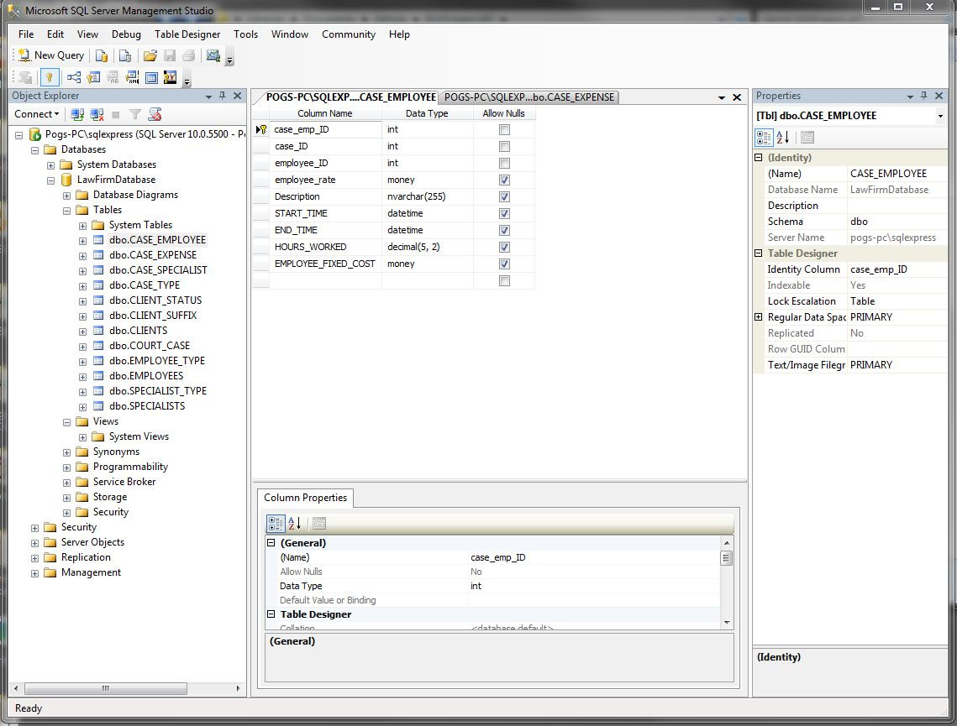

Application Design: The team is using Visual Basic 2012 with Lightswitch. The software allows us to have a GUI already in place, thus we can concentrate more on data validation. Using this software allows us to connect to a database with an interface we can test on. We can focus on putting data where it's needed and calculating it. This software also allows applications to be run on multiple machines, and to write to the database live provided there is sufficient equipment.

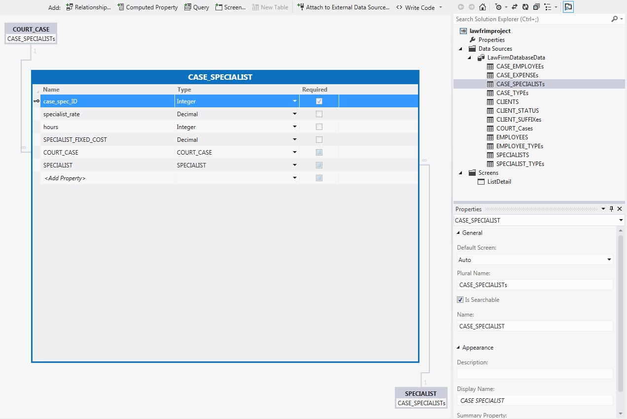

### Database:

During the beginning phases of the project, this was one our major undertakings. We spent quite a bit of time asking our sponsors what the system needed to do. After many questions, we had an idea on what the attorneys wanted. We spent several weeks designing the database based on the user requirements, and from a forum they gave us. After a few revisions we eventually came to a database we all agreed that was correct for this project.

This is what we currently have after several discussions on how the application should work, and after some testing. The database is currently a work in progress; things might change over time as we figure out more.

**Database Schema:**

|  |
| --- |
| RELATIONSHIPS |
| MANY employees TO MANY cases  ONE client TO MANY cases  MANY specialists TO MANY cases  MANY cases TO MANY expenses |

|  |
| --- |
| ENTITIES |
| CLIENTS, EMPLOYEES, COURT_CASE, SPECIALISTS, CASE_EMPLOYEE, CASE_SPECIALIST, CASE_EXPENSES  LOOKUPS:  CLIENT_STATUS  CLIENT_SUFFIX  EMPLOYEE_TYPE  CASE_TYPE  SPECIALIST_TYPE |

|  |
| --- |
| DBDL |
| **CLIENTS**(CLIENT_ID, CLIENT_STATUS_ID, APP_RET_DATE , CLIENT_SUFFIX_ID, FIRST_NAME, LAST_NAME, DOB, STREET_ADDRESS, CITY, STATE, ZIP, PHONE, JID_CDC, SSN, DRIVER_LICENSE, EMAIL )  PK CLIENT_ID  FK CLIENT_STATUS_ID 🡺 CLIENT_STATUS  FK CLIENT_SUFFIX_ID 🡺 CLIENT_SUFFIX  **CLIENT_STATUS**(CLIENT_STATUS_ID, CLIENT_STATUS)  PK CLIENT_STATUS_ID  **CLIENT_SUFFIX**(CLIENT_SUFFIX_ID, CLIENT_SUFFIX)  PK CLIENT_SUFFIX_ID  **EMPLOYEES**(EMPLOYEE_ID, EMPLOYEE_TYPE_ID, FIRST_NAME, LAST_NAME, DOB, STREET_ADDRESS, CITY, STATE, ZIP, PHONE, EMAIL)  PK EMPLOYEE_ID  FK EMPLOYEE_TYPE_ID 🡺 EMPLOYEE_TYPE  **EMPLOYEE_TYPE**(EMPLOYEE_TYPE_ID, EMPLOYEE_TYPE)  PK EMPLOYEE_TYPE_ID  **COURT_CASE**(CASE_ID, CASE_NUMBER, CASE_CATEGORY_ID, CLIENT_ID, CASE_TYPE, CASE_TITLE, CASE_DATE, CLIENT_RELATIONSHIP, NOTES, CLIENT_RELA_ID,)  PK CASE_ID  FK CASE_CATEGORY_ID 🡺 CASE_CATEGORIES  FK CLIENT_ID 🡺 CLIENTS  FK CLIENT_RELA_ID 🡺 CLIENT_RELATIONSHIP  **CASE_TYPE**(CASE_CATEGORY_ID, TITLE, AMOUNT)  PK CASE_CATEGORY_ID  **SPECIALISTS**(SPECIALIST_ID, FIRST_NAME, LAST_NAME, PHONE, EMAIL, STREET_ADDRESS, CITY, STATE, ZIP SPECIALIST_TYPE_ID)  PK SPECIALIST_ID  FK SPECIALIST_TYPE_ID 🡺 SPECIALIST_TYPE  **SPECIALIST_TYPE**(SPECIALIST_TYPE_ID, SPECIALIST_TYPE)  PK SPECIALIST_TYPE_ID  **CASE_EMPLOYEE**(CASE_EMP_ID, CASE_ID, EMPLOYEE_ID, EMPLOYEE _RATE, START_TIME, END_TIME, HOURS_WORKED, EMPLOYEE_FIXED_COST)  PK CASE_EMP_ID  FK CASE_ID 🡺 COURT_CASE  FK EMPLOYEE_ID 🡺 EMPLOYEES  **CASE_SPECIALIST**(CASE_SPEC_ID, CASE_ID, SPECIALIST_ID, SPECIALIST_RATE, HOURS, SPECIALIST_FIXED_COST)  PK CASE_SPEC_ID  FK CASE_ID 🡺 COURT_CASE  FK SPECIALIST_ID 🡺 SPECIALISTS  **CASE_EXPENSES**(CASE_EXP_ID, CASE_ID,DESCRIPTION, EXPENSE_COST)  PK CASE_EXP_ID  FK CASE_ID 🡺 COURT_CASE  **CLIENT_RELATIONSHIP**(CLIENT_RELA_ID, CLIENT_RELATIONSHIP)  PK CLIENT_RELA_ID |
|  |

**Entity Relationship Diagram:**

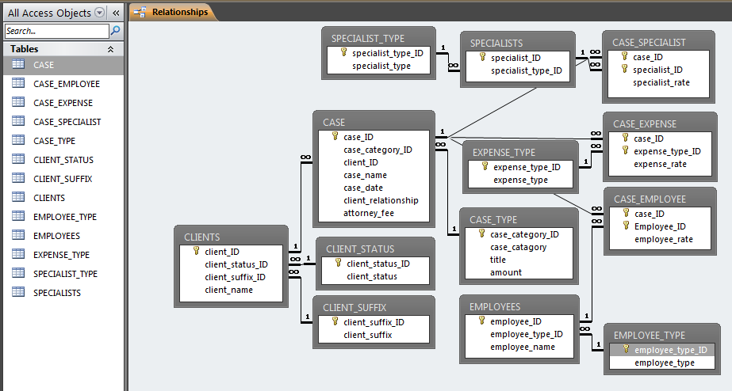

Here are the scripts we used to create the tables within Microsoft SQL Express. Using these scripts allows us to alter tables easier. If we forgot to add an attribute all we have to do is add a few lines to the script and run it in MS SQL Express.

### Database Scripts:

**Table CASE_EMPLOYEE:**

USE [LawFirmDRM22]

GO

/****** Object: Table [dbo].[CASE_EMPLOYEE] Script Date: 9/21/2012 8:35:17 PM ******/

SET ANSI_NULLS ON

GO

SET QUOTED_IDENTIFIER ON

GO

CREATE TABLE [dbo].[CASE_EMPLOYEE](

[case_emp_ID][int]IDENTITY(1,1) NOT NULL,

[case_ID] [int] NOT NULL,

[employee_ID] [int] NOT NULL,

[employee_rate] [money] NULL,

[Description][nvarchar](255) NULL,

[START_TIME][datetime] NULL,

[END_TIME][datetime] NULL,

[HOURS_WORKED][decimal](5,2) NULL,

[EMPLOYEE_FIXED_COST][money] NULL

CONSTRAINT [PK_CASE_EMP_ID] PRIMARY KEY CLUSTERED

(

[case_emp_ID] ASC

)WITH (PAD_INDEX = OFF, STATISTICS_NORECOMPUTE = OFF, IGNORE_DUP_KEY = OFF, ALLOW_ROW_LOCKS = ON, ALLOW_PAGE_LOCKS = ON) ON [PRIMARY]

) ON [PRIMARY]

GO

ALTER TABLE [dbo].[CASE_EMPLOYEE] WITH CHECK ADD CONSTRAINT [FK_CASE_ID] FOREIGN KEY([case_ID])

REFERENCES [dbo].[COURT_CASE] ([case_ID]) on delete cascade

GO

ALTER TABLE [dbo].[CASE_EMPLOYEE] CHECK CONSTRAINT [FK_CASE_ID]

GO

ALTER TABLE [dbo].[CASE_EMPLOYEE] WITH CHECK ADD CONSTRAINT [FK_EMPLOYEE_ID] FOREIGN KEY([employee_ID])

REFERENCES [dbo].[EMPLOYEES] ([employee_ID]) on delete cascade

GO

ALTER TABLE [dbo].[CASE_EMPLOYEE] CHECK CONSTRAINT [FK_EMPLOYEE_ID]

GO

**Table CASE_EXPENSES:**

USE [LawFirmDRM2]

GO

/****** Object: Table [dbo].[CASE_EXPENSE] Script Date: 9/21/2012 8:41:27 PM ******/

SET ANSI_NULLS ON

GO

SET QUOTED_IDENTIFIER ON

GO

CREATE TABLE [dbo].[CASE_EXPENSE](

[case_exp_ID][int] IDENTITY(1,1) NOT NULL,

[case_ID] [int] NOT NULL,

[description][nvarchar](255),

[expense_cost] [money] NULL,

CONSTRAINT [PK_CASE_EXP_ID] PRIMARY KEY CLUSTERED

(

[case_exp_ID] ASC

)WITH (PAD_INDEX = OFF, STATISTICS_NORECOMPUTE = OFF, IGNORE_DUP_KEY = OFF, ALLOW_ROW_LOCKS = ON, ALLOW_PAGE_LOCKS = ON) ON [PRIMARY]

) ON [PRIMARY]

GO

ALTER TABLE [dbo].[CASE_EXPENSE] WITH CHECK ADD CONSTRAINT [FK_CASE_ID3] FOREIGN KEY([case_ID])

REFERENCES [dbo].[COURT_CASE] ([case_ID]) on delete cascade

GO

ALTER TABLE [dbo].[CASE_EXPENSE] CHECK CONSTRAINT [FK_CASE_ID3]

GO

**Table CASE_SPECIALIST:**

USE [LawFirmDRM2]

GO

/****** Object: Table [dbo].[CASE_SPECIALIST] Script Date: 9/21/2012 8:38:22 PM ******/

SET ANSI_NULLS ON

GO

SET QUOTED_IDENTIFIER ON

GO

CREATE TABLE [dbo].[CASE_SPECIALIST](

[case_spec_ID][int] IDENTITY(1,1) NOT NULL,

[case_ID] [int] NOT NULL,

[specialist_ID] [int] NOT NULL,

[specialist_rate] [money] NULL,

[hours][int],

[SPECIALIST_FIXED_COST][money]

CONSTRAINT [PK_CASE_SP_ID] PRIMARY KEY CLUSTERED

(

[case_spec_ID] ASC

)WITH (PAD_INDEX = OFF, STATISTICS_NORECOMPUTE = OFF, IGNORE_DUP_KEY = OFF, ALLOW_ROW_LOCKS = ON, ALLOW_PAGE_LOCKS = ON) ON [PRIMARY]

) ON [PRIMARY]

GO

ALTER TABLE [dbo].[CASE_SPECIALIST] WITH CHECK ADD CONSTRAINT [FK_CASE_ID2] FOREIGN KEY([case_ID])

REFERENCES [dbo].[COURT_CASE] ([case_ID]) on delete cascade

GO

ALTER TABLE [dbo].[CASE_SPECIALIST] CHECK CONSTRAINT [FK_CASE_ID2]

GO

ALTER TABLE [dbo].[CASE_SPECIALIST] WITH CHECK ADD CONSTRAINT [FK_SP_ID2] FOREIGN KEY([specialist_ID])

REFERENCES [dbo].[SPECIALISTS] ([specialist_ID]) on delete cascade

GO

ALTER TABLE [dbo].[CASE_SPECIALIST] CHECK CONSTRAINT [FK_SP_ID2]

GO

Table CASE_TYPE:

USE [LawFirmDRM2]

GO

/****** Object: Table [dbo].[CASE_TYPE] Script Date: 9/21/2012 8:18:47 PM ******/

SET ANSI_NULLS ON

GO

SET QUOTED_IDENTIFIER ON

GO

CREATE TABLE [dbo].[CASE_TYPE](

[case_category_ID] [int] IDENTITY(1,1) NOT NULL,

[case_catagory] [nvarchar](255) NOT NULL,

[title] [nvarchar](255) NULL,

[amount] [money]

CONSTRAINT [PK_CASE_CAT_ID] PRIMARY KEY CLUSTERED

(

[case_category_ID] ASC

)WITH (PAD_INDEX = OFF, STATISTICS_NORECOMPUTE = OFF, IGNORE_DUP_KEY = OFF, ALLOW_ROW_LOCKS = ON, ALLOW_PAGE_LOCKS = ON) ON [PRIMARY]

) ON [PRIMARY]

GO

**Table CLIENT_RELATIONSHIP:**

USE [LawFirmDRM2]

GO

/****** Object: Table [dbo].[CLIENT_RELATIONSHIP] Script Date: 10/8/2012 12:02:25 PM ******/

SET ANSI_NULLS ON

GO

SET QUOTED_IDENTIFIER ON

GO

CREATE TABLE [dbo].[CLIENT_RELATIONSHIP](

[CLIENT_RELA_ID] [int] IDENTITY(1,1) NOT NULL,

[CLIENT_RELATIONSHIP] [nvarchar](255) NULL,

CONSTRAINT [PK_CLIENT_RELA_ID] PRIMARY KEY CLUSTERED

(

[CLIENT_RELA_ID] ASC

)WITH (PAD_INDEX = OFF, STATISTICS_NORECOMPUTE = OFF, IGNORE_DUP_KEY = OFF, ALLOW_ROW_LOCKS = ON, ALLOW_PAGE_LOCKS = ON) ON [PRIMARY]

) ON [PRIMARY]

GO

**Table CLIENT_STATUS:**

USE [LawFirmDRM2]

GO

/****** Object: Table [dbo].[CLIENT_STATUS] Script Date: 9/21/2012 8:13:28 PM ******/

SET ANSI_NULLS ON

GO

SET QUOTED_IDENTIFIER ON

GO

CREATE TABLE [dbo].[CLIENT_STATUS](

[client_status_ID] [int] IDENTITY(1,1) NOT NULL,

[client_status] [nvarchar](25) NOT NULL,

CONSTRAINT [PK_CLIENT_STATUS_ID] PRIMARY KEY CLUSTERED

(

[client_status_ID] ASC

)WITH (PAD_INDEX = OFF, STATISTICS_NORECOMPUTE = OFF, IGNORE_DUP_KEY = OFF, ALLOW_ROW_LOCKS = ON, ALLOW_PAGE_LOCKS = ON) ON [PRIMARY]

) ON [PRIMARY]

GO

**Table CLIENT_SUFFIX:**

USE [LawFirmDRM2]

GO

/****** Object: Table [dbo].[CLIENT_SUFFIX] Script Date: 9/21/2012 8:15:52 PM ******/

SET ANSI_NULLS ON

GO

SET QUOTED_IDENTIFIER ON

GO

CREATE TABLE [dbo].[CLIENT_SUFFIX](

[client_suffix_ID] [int] IDENTITY(1,1) NOT NULL,

[client_suffix] [nvarchar](25) NOT NULL,

CONSTRAINT [PK_CLIENT_SUFFIX_ID] PRIMARY KEY CLUSTERED

(

[client_suffix_ID] ASC

)WITH (PAD_INDEX = OFF, STATISTICS_NORECOMPUTE = OFF, IGNORE_DUP_KEY = OFF, ALLOW_ROW_LOCKS = ON, ALLOW_PAGE_LOCKS = ON) ON [PRIMARY]

) ON [PRIMARY]

GO

**Table CLIENTS:**

USE [LawFirmDRM2]

GO

/****** Object: Table [dbo].[CLIENTS] Script Date: 9/21/2012 8:23:26 PM ******/

SET ANSI_NULLS ON

GO

SET QUOTED_IDENTIFIER ON

GO

CREATE TABLE [dbo].[CLIENTS](

[client_ID] [int] IDENTITY(1,1) NOT NULL,

[client_status_ID] [int] NOT NULL,

[app_ret_date][datetime] NOT NULL,

[client_suffix_ID] [int] NOT NULL,

[first_name] [nvarchar](255) NOT NULL,

[last_name][nvarchar](255) NOT NULL,

[DOB][datetime],

[STREET_ADDRESS][nvarchar](255),

[CITY][varchar](100) ,

[STATE][char](2),

[ZIP][int] ,

[JID_CDC][nvarchar](100),

[SSN][int],

[DRIVER_LICENSE][nvarchar](25),

[EMAIL][nvarchar](50),

[PHONE][nvarchar](20)

CONSTRAINT [PK_CLIENT_ID] PRIMARY KEY CLUSTERED

(

[client_ID] ASC

)WITH (PAD_INDEX = OFF, STATISTICS_NORECOMPUTE = OFF, IGNORE_DUP_KEY = OFF, ALLOW_ROW_LOCKS = ON, ALLOW_PAGE_LOCKS = ON) ON [PRIMARY]

) ON [PRIMARY]

GO

ALTER TABLE [dbo].[CLIENTS] WITH CHECK ADD CONSTRAINT [FK_CLIENT_STATUS_ID] FOREIGN KEY([client_status_ID])

REFERENCES [dbo].[CLIENT_STATUS] ([client_status_ID])

GO

ALTER TABLE [dbo].[CLIENTS] CHECK CONSTRAINT [FK_CLIENT_STATUS_ID]

GO

ALTER TABLE [dbo].[CLIENTS] WITH CHECK ADD CONSTRAINT [FK_CLIENT_SUFFIX_ID] FOREIGN KEY([client_suffix_ID])

REFERENCES [dbo].[CLIENT_SUFFIX] ([client_suffix_ID])

GO

ALTER TABLE [dbo].[CLIENTS] CHECK CONSTRAINT [FK_CLIENT_SUFFIX_ID]

GO

**Table COURT_CASE:**

USE [LawFirmDRM2]

GO

/****** Object: Table [dbo].[COURT_CASE] Script Date: 9/21/2012 8:30:14 PM ******/

SET ANSI_NULLS ON

GO

SET QUOTED_IDENTIFIER ON

GO

CREATE TABLE [dbo].[COURT_CASE](

[case_ID] [int] IDENTITY(1,1) NOT NULL,

[case_number][varchar](255),

[case_category_ID] [int] NULL,

[client_ID] [int] NOT NULL,

[case_type][nvarchar](255) NULL,

[case_title] [nvarchar](255) NOT NULL,

[case_date] [datetime] NULL,

[client_relationship] [nvarchar](255) NULL,

[notes][nvarchar](255) NULL,

CONSTRAINT [PK_CASE_ID] PRIMARY KEY CLUSTERED

(

[case_ID] ASC

)WITH (PAD_INDEX = OFF, STATISTICS_NORECOMPUTE = OFF, IGNORE_DUP_KEY = OFF, ALLOW_ROW_LOCKS = ON, ALLOW_PAGE_LOCKS = ON) ON [PRIMARY]

) ON [PRIMARY]

GO

ALTER TABLE [dbo].[COURT_CASE] WITH CHECK ADD CONSTRAINT [FK_CASE_CAT_ID] FOREIGN KEY([case_category_ID])

REFERENCES [dbo].[CASE_TYPE] ([case_category_ID])

GO

ALTER TABLE [dbo].[COURT_CASE] CHECK CONSTRAINT [FK_CASE_CAT_ID]

GO

ALTER TABLE [dbo].[COURT_CASE] WITH CHECK ADD CONSTRAINT [FK_CLIENT_ID] FOREIGN KEY([client_ID])

REFERENCES [dbo].[CLIENTS] ([client_ID])

GO

ALTER TABLE [dbo].[COURT_CASE] CHECK CONSTRAINT [FK_CLIENT_ID]

GO

**Table EMPLOYEE_TYPE:**

USE [LawFirmDRM2

GO

/****** Object: Table [dbo].[EMPLOYEE_TYPE] Script Date: 9/21/2012 8:17:16 PM ******/

SET ANSI_NULLS ON

GO

SET QUOTED_IDENTIFIER ON

GO

CREATE TABLE [dbo].[EMPLOYEE_TYPE](

[employee_type_ID] [int] IDENTITY(1,1) NOT NULL,

[employee_type] [nvarchar](255) NULL,

CONSTRAINT [PK_EMPLYEE_TYPE_ID] PRIMARY KEY CLUSTERED

(

[employee_type_ID] ASC

)WITH (PAD_INDEX = OFF, STATISTICS_NORECOMPUTE = OFF, IGNORE_DUP_KEY = OFF, ALLOW_ROW_LOCKS = ON, ALLOW_PAGE_LOCKS = ON) ON [PRIMARY]

) ON [PRIMARY]

GO

**Table EMPLOYEES:**

USE [LawFirmDRM2]

GO

/****** Object: Table [dbo].[EMPLOYEES] Script Date: 9/21/2012 8:27:58 PM ******/

SET ANSI_NULLS ON

GO

SET QUOTED_IDENTIFIER ON

GO

CREATE TABLE [dbo].[EMPLOYEES](

[employee_ID] [int] IDENTITY(1,1) NOT NULL,

[employee_type_ID] [int] NULL,

[first_name] [nvarchar](255) NOT NULL,

[last_name][nvarchar](255) NOT NULL,

[DOB][datetime],

[STREET_ADDRESS][nvarchar](255),

[CITY][varchar](100) ,

[STATE][char](2),

[ZIP][int],

[EMAIL][nvarchar](50),

[PHONE][nvarchar](20)

CONSTRAINT [PK_EMPLOYEE_ID] PRIMARY KEY CLUSTERED

(

[employee_ID] ASC

)WITH (PAD_INDEX = OFF, STATISTICS_NORECOMPUTE = OFF, IGNORE_DUP_KEY = OFF, ALLOW_ROW_LOCKS = ON, ALLOW_PAGE_LOCKS = ON) ON [PRIMARY]

) ON [PRIMARY]

GO

ALTER TABLE [dbo].[EMPLOYEES] WITH CHECK ADD CONSTRAINT [FK_EMPLYEE_TYPE_ID] FOREIGN KEY([employee_type_ID])

REFERENCES [dbo].[EMPLOYEE_TYPE] ([employee_type_ID])

GO

ALTER TABLE [dbo].[EMPLOYEES] CHECK CONSTRAINT [FK_EMPLYEE_TYPE_ID]

GO

**Table EXPENSE_TYPE:**

USE [LawFirm]

GO

/****** Object: Table [dbo].[EXPENSE_TYPE] Script Date: 9/21/2012 8:22:31 PM ******/

SET ANSI_NULLS ON

GO

SET QUOTED_IDENTIFIER ON

GO

CREATE TABLE [dbo].[EXPENSE_TYPE](

[expense_type_ID] [int] IDENTITY(1,1) NOT NULL,

[expense_type] [nvarchar](255) NULL,

CONSTRAINT [PK_EXP_TYPE_ID] PRIMARY KEY CLUSTERED

(

[expense_type_ID] ASC

)WITH (PAD_INDEX = OFF, STATISTICS_NORECOMPUTE = OFF, IGNORE_DUP_KEY = OFF, ALLOW_ROW_LOCKS = ON, ALLOW_PAGE_LOCKS = ON) ON [PRIMARY]

) ON [PRIMARY]

GO

**Table SPECIALIST_TYPE:**

USE [LawFirmDRM2]

GO

/****** Object: Table [dbo].SPECIALIST_TYPE] Script Date: 9/21/2012 8:22:31 PM ******/

SET ANSI_NULLS ON

GO

SET QUOTED_IDENTIFIER ON

GO

CREATE TABLE [dbo].[SPECIALIST_TYPE](

[SPECIALIST_type_ID] [int] IDENTITY(1,1) NOT NULL,

[SPECIALIST_type] [nvarchar](255) NULL,

CONSTRAINT [PK_SP_TYPE_ID] PRIMARY KEY CLUSTERED

(

[SPECIALIST_type_ID] ASC

)WITH (PAD_INDEX = OFF, STATISTICS_NORECOMPUTE = OFF, IGNORE_DUP_KEY = OFF, ALLOW_ROW_LOCKS = ON, ALLOW_PAGE_LOCKS = ON) ON [PRIMARY]

) ON [PRIMARY]

GO

**Table SPECIALIST:**

USE [LawFirmDRM2]

GO

/****** Object: Table [dbo].[SPECIALISTS] Script Date: 9/21/2012 8:33:59 PM ******/

SET ANSI_NULLS ON

GO

SET QUOTED_IDENTIFIER ON

GO

CREATE TABLE [dbo].[SPECIALISTS](

[specialist_ID] [int] IDENTITY(1,1) NOT NULL,

[specialist_type_ID] [int] NULL,

[first_name] [nvarchar](255) NOT NULL,

[last_name][nvarchar](255) NOT NULL,

[DOB][datetime],

[STREET_ADDRESS][nvarchar](255),

[CITY][varchar](100) ,

[STATE][char](2),

[ZIP][int],

[EMAIL][nvarchar](50),

[PHONE][nvarchar](20)

CONSTRAINT [PK_SP_ID] PRIMARY KEY CLUSTERED

(

[specialist_ID] ASC

)WITH (PAD_INDEX = OFF, STATISTICS_NORECOMPUTE = OFF, IGNORE_DUP_KEY = OFF, ALLOW_ROW_LOCKS = ON, ALLOW_PAGE_LOCKS = ON) ON [PRIMARY]

) ON [PRIMARY]

GO

ALTER TABLE [dbo].[SPECIALISTS] WITH CHECK ADD CONSTRAINT [FK_SP_TYPE_ID] FOREIGN KEY([specialist_type_ID])

REFERENCES [dbo].[SPECIALIST_TYPE] ([specialist_type_ID])

GO

ALTER TABLE [dbo].[SPECIALISTS] CHECK CONSTRAINT [FK_SP_TYPE_ID]

GO

### GUI Design:

A few screen shots of what the application will look like. We based the workflow of the application off a diagram we created. Below shows the diagram and how it influenced the application interface. While it is basic looking right now, we plan to give it more flare.

Search

Yes

Details

Result

No

Save

Add

### Screenshots of Application:

**Search for Court Case(s):**

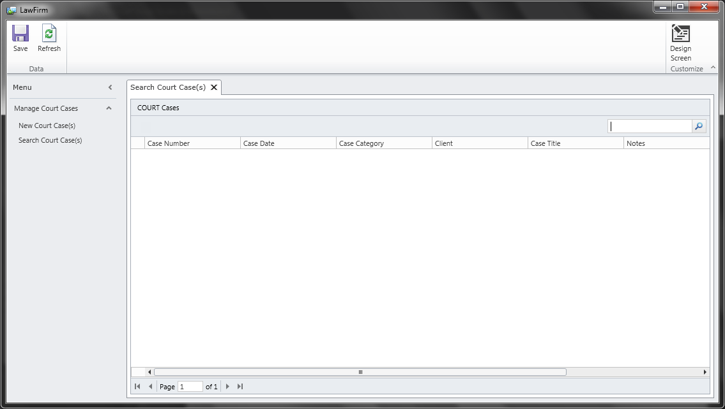

**Add New Court Case(s):**

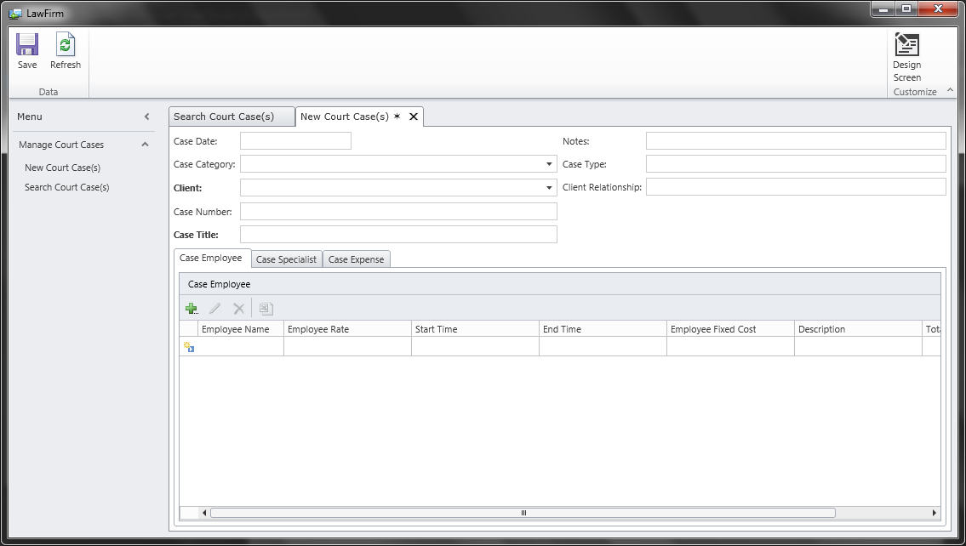

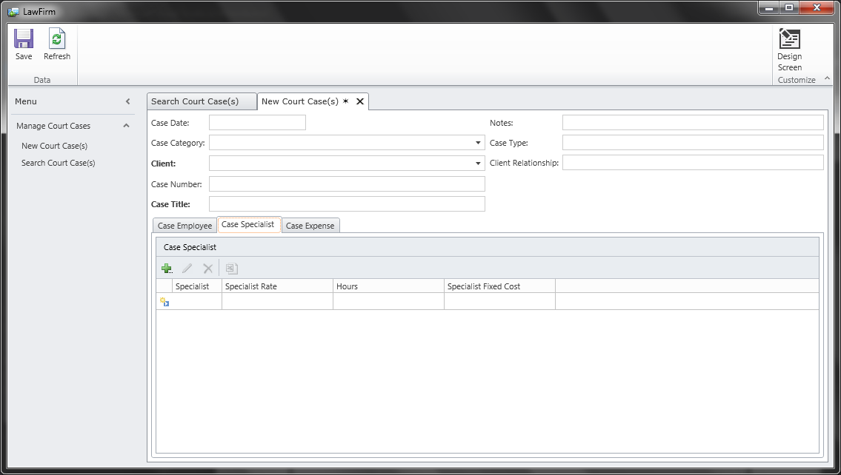

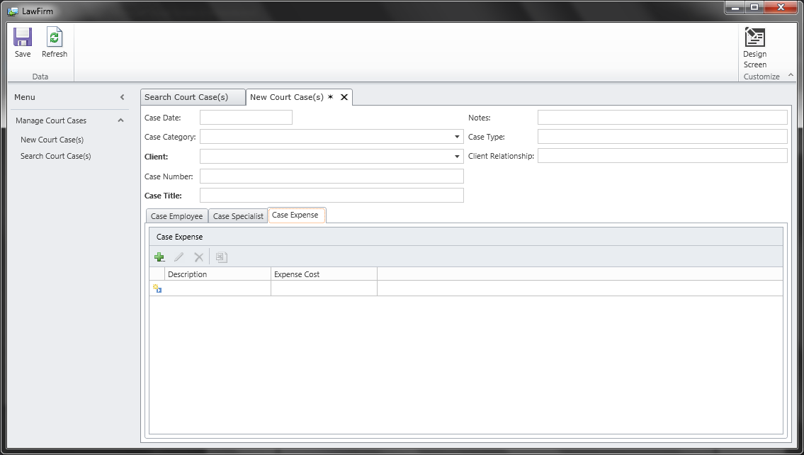

### Future Development:

In the next following weeks, the team is going to focus on figuring out how to display calculated fields within the application. There is the matter of doing the logic for all the calculations that is required for the application to do. The report is what seems to worry the team the most, perhaps the hardest part of the project. The report shows all the data, and the remaining funds left from a case.

Below shows what the report should look like. This forum is what the attorneys turn in for court cases assigned by the county.

|  |  |  |  |
| --- | --- | --- | --- |
| **NAME AND ADDRESS OF VENDOR:                         PHONE:** | | For Court Use Only: | |
| **SUPERIOR COURT OF CALIFORNIA, COUNTY OF FRESNO**  **1100 Van Ness Avenue**  **Fresno, CA 93724-0002** | |
| APPLICATION AND ORDER FOR PAYMENT OF COURT APPOINTED VENDOR  **(Not to be used for court appointed special circumstance attorney claims)** | | | |
| **CASE NAME:** | | | **CASE NUMBER:** |
| **NOTE TO ALL VENDORS: COPY OF COURT ORDER APPOINTING VENDOR MUST ACCOMPANY THIS FORM.** | | | |
| **STANDARD RATE PSYCHOLOGICAL/**  **PSYCHIATRIC EVALUATION CLAIM:**  a. Date appointed:  by Judge  b. Evaluation date:  c. Type of evaluation:  d. Fee:  NOTE: If you have written**preapproval** for more than  the standard rate, fill out the expert services portion of  this form. | **COURT APPOINTED SERVICES (EXPERT, INVESTIGATOR, ETC.) CLAIM:**  (Provide Attachment A for itemization of services and mileage, and  Attachment B with original receipts for expenses.)  a.                       hours at $                         per hour                                 $ 0.00  b. Mileage (                   miles at $        per mile)                               $ 0.00  c. Expenses 0.00                                                                                      $ 0.00  **TOTAL                                                  $** 0.00 | | |
| **Signature of attorney of record required on Attachment A for expert or**  **investigator billing prior to submission.** | | |
| **COURT APPOINTED ATTORNEY DECLARATION AND CLAIM:**  I am an attorney at law duly admitted to practice in the State of California. I have not received compensation for this claim except as noted  below. I hereby make application for payment of fees as follows:  (See footnote * below before completing.)  A. Appointed on (date)                                               to represent (name)  (Client’s relationship to case:                                                                  )  B. This is the only billing for this case and legal services have been terminated  and required less than 3 hours - flat fee $240    $                                Expenses: $  C. Interim billing for services from                                             to  (If interim billing, date of prior billing:                                                                            )  D. Legal services terminated on or about (date):  E. Attorney’s fees: $                                                           Expenses: $***(other than $240 flat fee)***  **Total amount claimed for A through E** (Provide Attachment A for itemization of  services and Attachment B with original receipts for expenses):**TOTAL** $ 0.00 | | | |
| I declare under penalty of perjury that the foregoing is true and correct and that this declaration is executed on (Date):                               ,  at (Place)                                                                     , California.  (Type or print name)                                                                                                            (Signature of applicant) | | | |

FOR COURT USE ONLY:                                ORDER

The foregoing application has been considered and the court finds the following fees to be reasonable:

a. Fees: $

b. Expenses $

c. Mileage $

**TOTAL:** $

It is ordered that the total shown above in item 2c be paid by Fresno County Superior Court.

Dated: Judge of the Superior Court

*Declarations under penalty of perjury signed in California may be used in place of affidavits (CCP 2015.5).

Affidavits required when signed outside California.

**APPLICATION AND ORDER FOR PAYMENT OF COURT APPOINTED VENDOR FEES AND EXPENSES**

## **Milestone Report 2**

**Law Firm BPR Team**

**Project Name: Law Firm Billing Project**

**Report Date: November 29, 2012**

Team Members:

Albert Badalyan Database Administrator

Colin Kay Project Manager

Kaleb Martens GUI Developer

Pagoda Pang Technical Writer

### Back End Design:

Much has changed within the last month, we figured out how things are calculated within the billing process. Our database has change drastically we added some new fields and even took out some. Calculated fields have been placed in the system, time can be tracked and funds can be viewed live. We also implemented the report feature within the application. Clicking on the button will launch the report feature, the report will display with the available data that has been inputted.

Details of what we have done from the back end of things are explained throughout thereport.

This is what we have currently in our database, things were added and some were removed. Throughout the project this was a normal routine for us, as we would go back and forth discussing what is really needed. It was hard for us to understand all of the billing details, even now we are baffled on how much goes on during this process.

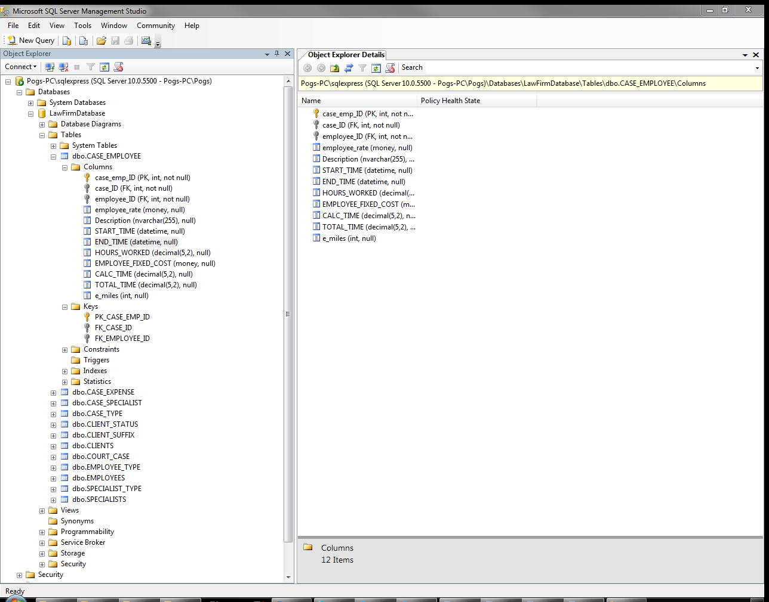

Provided is the formula we will use to calculate the expenses per case, then identify the amount of funds available left for that case.

|  |  |  |  |
| --- | --- | --- | --- |
| Case Employee | | | |
| Start Time/End Time | Hours Worked | Hourly | Fixed Fee |
|  |  |  |  |
| Total Case Employee Cost per Case | | | |

|  |  |
| --- | --- |
| Specialist | |
| Hours | Cost |
|  |  |
| Total Specialist Cost + Total Case Employee Cost | |

|  |
| --- |
| Expenses |
| Cost |
|  |
| Total Expenses + Total Specialist Cost + Total Case Employee Cost |

The will be deducted from total fund amount to determine how much money is allocated per case.

Provided is the VB code which utilizes the expense formulas to perform the following:

1. Calculate the total cost for case employees, specialists, and any additional expenses, then display the calculated amount on the Court Case screen as “Expenses”
2. Deduct the total expenses from the amount allocated to that case type, then display the calculated amount on the Court Case screen as “Money Pool”

Namespace LightSwitchApplication

Public Class COURT_CASE

Private Sub Total_Expenses_Compute(ByRef result As Decimal)

' Set result to the desired field value

Dim expenses As Integer

Dim emp_fees As Integer

Dim emp_fixed_cost As Integer

Dim spc_fees As Integer

Dim spc_fixed_cost As Integer

' Calculate fixed and hourly fees for employees

emp_fees = CASE_EMPLOYEEs.Sum(Function(f) f.Employee_Rate * f.CALC_TIME)

emp_fixed_cost = CASE_EMPLOYEEs.Sum(Function(g) g.EMPLOYEE_FIXED_COST)

' Calculate additional case expenses

expenses = CASE_EXPENSEs.Sum(Function(e) e.expense_cost)

' Calculate fixed and hourly fees for specialists

spc_fees = CASE_SPECIALISTs.Sum(Function(s) s.Specialist_Rate * s.hours)

spc_fixed_cost = CASE_SPECIALISTs.Sum(Function(sp) sp.SPECIALIST_FIXED_COST)

result = expenses + emp_fees + emp_fixed_cost + spc_fees + spc_fixed_cost

End Sub

Private Sub Money_Pool_Compute(ByRef result As Decimal)

' Set result to the desired field value

If CASE_TYPE Is Nothing Then

result = 0

Else

result = CASE_TYPE.amount - Total_Expenses

End If

End Sub

To launch the sp_CalcTime stored procedure, VB code was applied to the sp_CourtCase application table and Court_CaseDETAIL screen . Provided is the VB code for the sp_CalcTime application table:

Imports System.Data

Imports System.Data.SqlClient

Namespace LightSwitchApplication

Public Class ApplicationDataService

Private Sub sp_CalcTime_Inserting(entity As sp_CalcTimeItem)

Using connection = New SqlConnection

Dim connectionStringName = Me.DataWorkspace.LawFirmData.Details.Name

connection.ConnectionString =

ConfigurationManager.ConnectionStrings(connectionStringName).ConnectionString

Dim procedure = "dbo.sp_CalcTime"

Using command = New SqlCommand(procedure, connection)

command.CommandType = CommandType.StoredProcedure

connection.Open()

command.ExecuteNonQuery()

End Using

End Using

Me.Details.DiscardChanges()

End Sub

Provided is the VB for the Court_CaseDETAIL screen that is executed when a record is being saved:

Private Sub Calc_Time_Execute()

' Write your code here.

Dim dataWorkspace = New DataWorkspace

Dim courtcase = Me.COURT_CASEcase_ID

Dim operation =

dataWorkspace.ApplicationData.sp_CalcTime.AddNew()

operation.CaseID = courtcase

dataWorkspace.ApplicationData.SaveChanges()

End Sub

Private Sub COURT_CASEDetail_Saved()

' Write your code here.

Dim dataWorkspace = New DataWorkspace

Dim courtcase = Me.COURT_CASEcase_ID

Dim operation =

dataWorkspace.ApplicationData.sp_CalcTime.AddNew()

dataWorkspace.ApplicationData.SaveChanges()

End Sub

Provided is the sp_CalcTime stored procedure that is executed when a new expense record is saved on the Court_CaseDETAIL screen:

/****** Object: StoredProcedure [dbo].[sp_CalcTime] Script Date: 11/28/2012 8:40:24 PM ******/

SET ANSI_NULLS ON

GO

SET QUOTED_IDENTIFIER ON

GO

ALTER procedure [dbo].[sp_CalcTime]

AS

/*

Changelog:

Date Comment

------------------------------------------------------------------------------------------------------------

10/18/12: Currenly can calculate the time difference for a single Case_Emp_ID that is provided in the script.

Ultimately, this script will calculate the CALC_TIME for each record in the dbo.case_employee table.

10/28/12: Procedure will now perform the date-time calculation for any existing record with a CASE_EMP_ID. Also

will update the CALC_TIME for each record unless the calculated time is < .5.

------------------------------------------------------------------------------------------------------------

*/

/* Declare variables to be used for calculations. */

DECLARE @sql1 nvarchar(255), @sql2 nvarchar(255), @date1 nvarchar(60), @date2 nvarchar(60), @calc decimal(7,2)

DECLARE @retval1 int, @retval2 int, @ParmDef1 nvarchar(255), @ParmDef2 nvarchar(255)

DECLARE @CaseEmpID int

/* Declare curor. */

DECLARE CaseEmpID CURSOR FOR

SELECT case_emp_id FROM [dbo].[case_employee];

OPEN CaseEmpID

FETCH NEXT FROM CaseEmpID

INTO @CaseEmpID

WHILE @@FETCH_STATUS = 0

BEGIN

/* Prepare query to capture output for @date1 (START_TIME) from sp_executesql. */

SET @sql1 = 'select @date1OUT = START_TIME from [dbo].[case_employee] where case_emp_ID =' +Convert(nvarchar,@CaseEmpID)+''

SET @ParmDef1 = N'@date1OUT datetime OUTPUT'

/* Execute @sql1 and capture the output into @date1 (START_TIME) for later calculations. */

EXEC sp_executesql @sql1, @ParmDef1, @date1OUT=@date1 OUTPUT;

/* Prepare query to capture output for @date2 (END_TIME) from sp_executesql. */

SET @sql2 = 'select @date2OUT = END_TIME from [dbo].[case_employee] where case_emp_ID =' +Convert(nvarchar,@CaseEmpID)+''

SET @ParmDef2 = N'@date2OUT datetime OUTPUT'

/* Execute @sql1 and capture the output into @date2 (END_TIME) for later calculations. */

EXEC sp_executesql @sql2, @ParmDef2, @date2OUT=@date2 OUTPUT;

/* Calculate and store the difference between the START_TME and END_TIME.

Also, divide the minutes calculated by 60 and convert to float for preserve decimal values.*/

set @calc = Convert(Float,DATEDIFF(minute, @date1, @date2)/60.0)

/*

Append the calculated difference to the record with matching case_emp_ID.

Update the CALC_TIME if @calc is greater, or equal to, .5. Otherwise, notify user.

*/

IF @calc >= .5

BEGIN

update [dbo].[case_employee]

set CALC_TIME = @calc

where case_emp_ID = @CaseEmpID

END

ELSE

update dbo.case_employee

set CALC_TIME = NULL

where case_emp_ID = @CaseEmpId

--PRINT 'The following Case_Emp_ID was not updated due to a negative value (END_TIME not present):' + Convert(varchar(10),@CaseEmpID)

FETCH NEXT FROM CaseEmpID INTO @CaseEmpID

END

CLOSE CaseEmpID

DEALLOCATE CaseEmpID

For the users to be able to render Court appointed report, the following VB script was developed. This code allows the user to utilize a “Launch Report” link on the Court_CaseDETAIL screen, which launches the court appointed report within the default internet browser. Once the report is loaded, the user can specify the specific date range of expenses that will be included on the report.

Private Sub Print_Execute()

' Write your code here.

Dispatchers.Main.BeginInvoke(

Sub()

Dim case_ID

case_ID = Me.COURT_CASEcase_ID

' Provide the URL for the report that you want to view

Dim uri As New Uri("http://amb-t61/ReportServer_EXPADV/Pages/ReportViewer.aspx?%2fReport+Project7%2fReport1&rs:Command=Render&CASE_ID=" & case_ID)

If (AutomationFactory.IsAvailable) Then

' This is a desktop app, so shell to the default browser

Dim shell = AutomationFactory.CreateObject("Shell.Application")

shell.ShellExecute(uri.ToString)

ElseIf (Not System.Windows.Application.Current.IsRunningOutOfBrowser) Then

' This is a web app, so navigate to the page

System.Windows.Browser.HtmlPage.Window.Navigate(uri, "_blank")

End If

End Sub)

End Sub

### GUI Design:

The front end of the application hasn't changed much in look and feel. However we did rearrange some of the fields and buttons to create a better workflow. Everything is consolidated under a billing category our sponsors use. Categories are broken up into specific topics such as cases, clients, employees, and specialists.

We were able to display the current amount of funds left in a case. The neat part about this is that calculations are done live and the user can see the funds decrease as they enter in more expenses. There is still some cleaning up to do, overall the scope requirements have been met.

Court Case search screen:

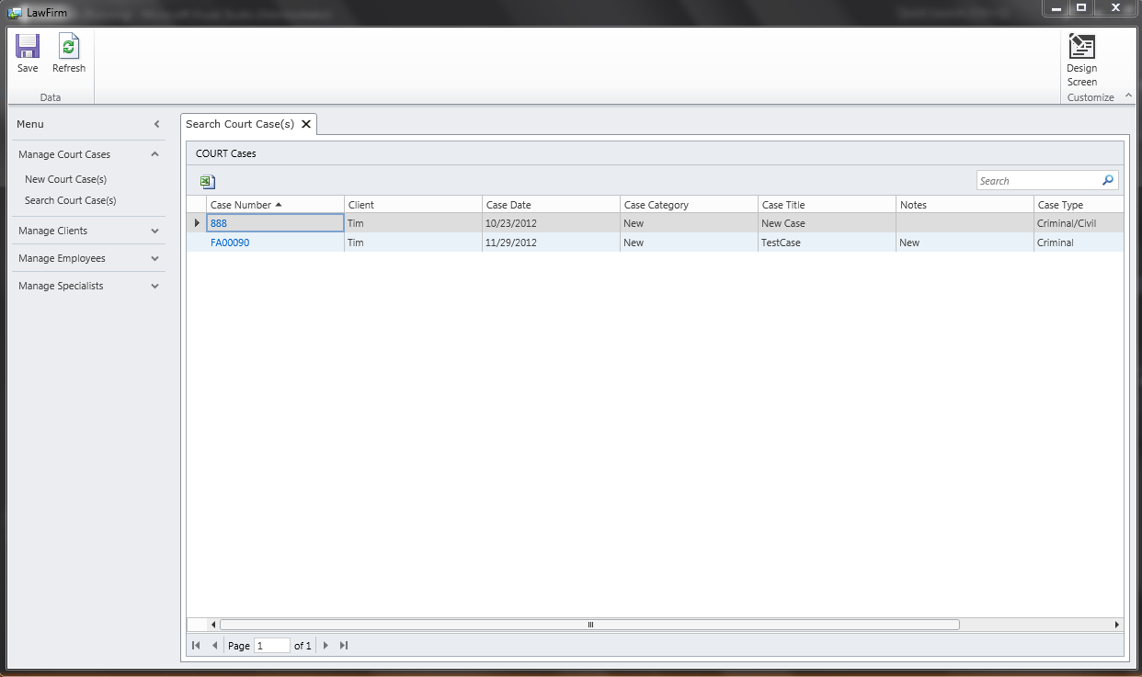

Court Case detail screen which shows Money Pool and Expenses:

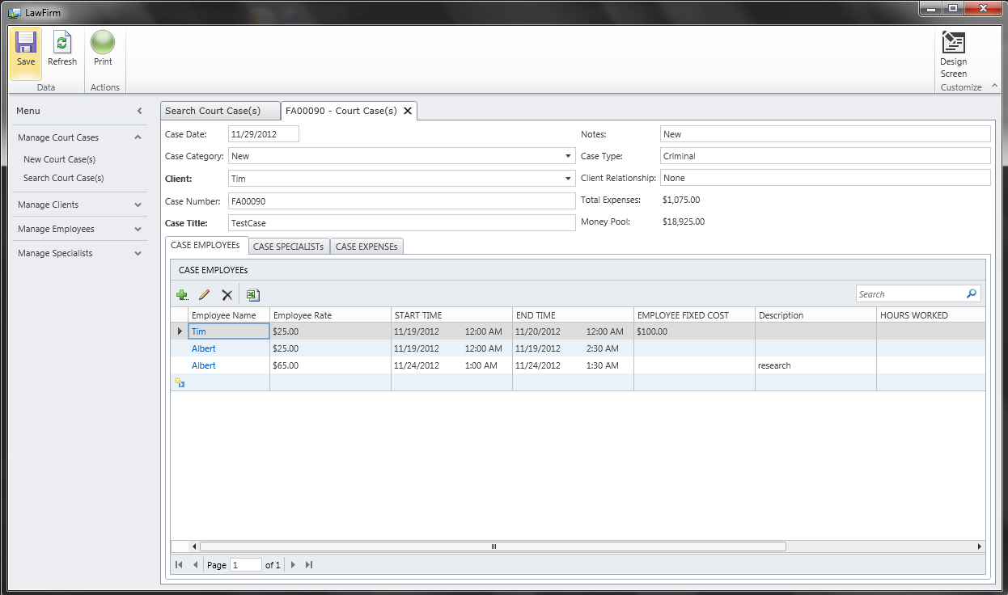

Client search screen:

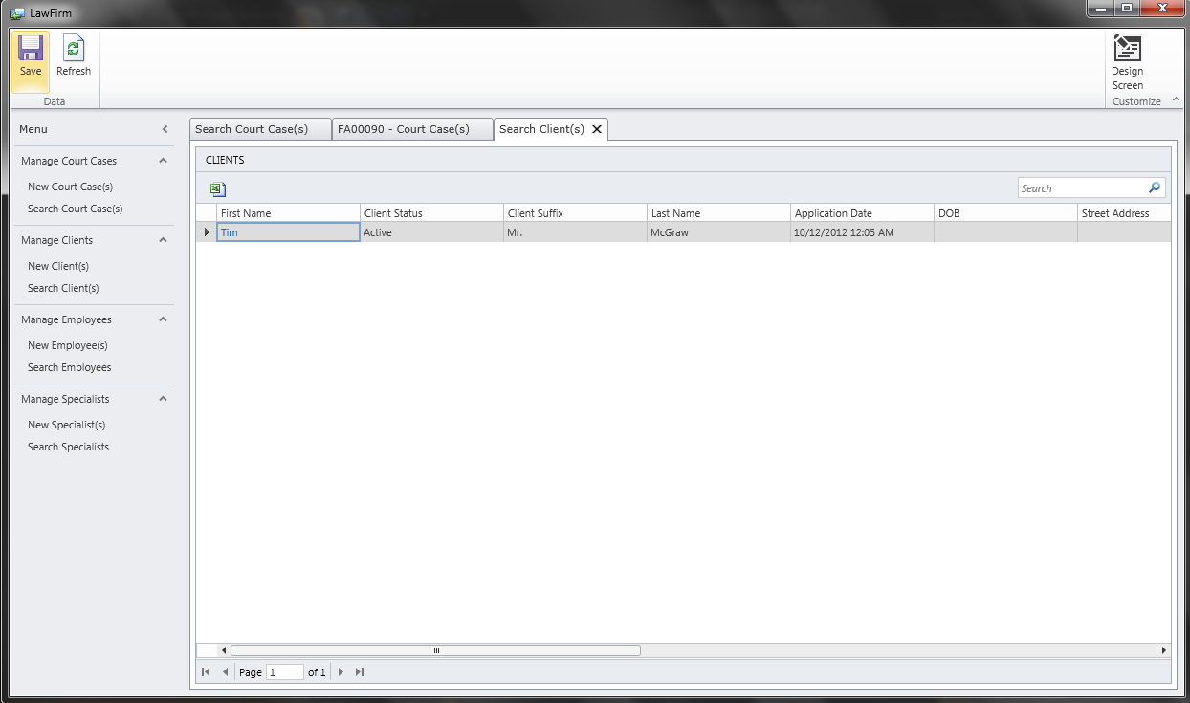

New client data entry screen:

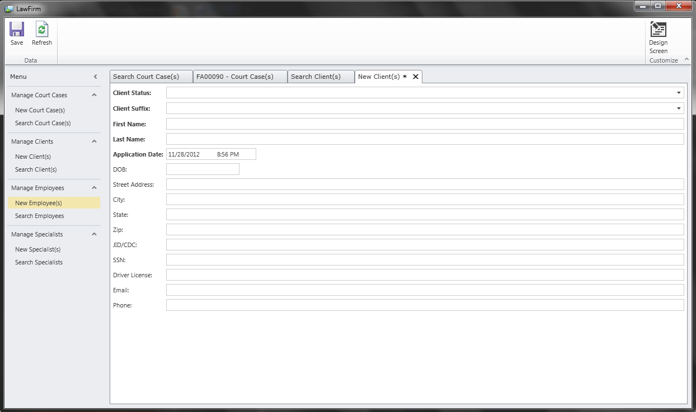

Employee search screen:

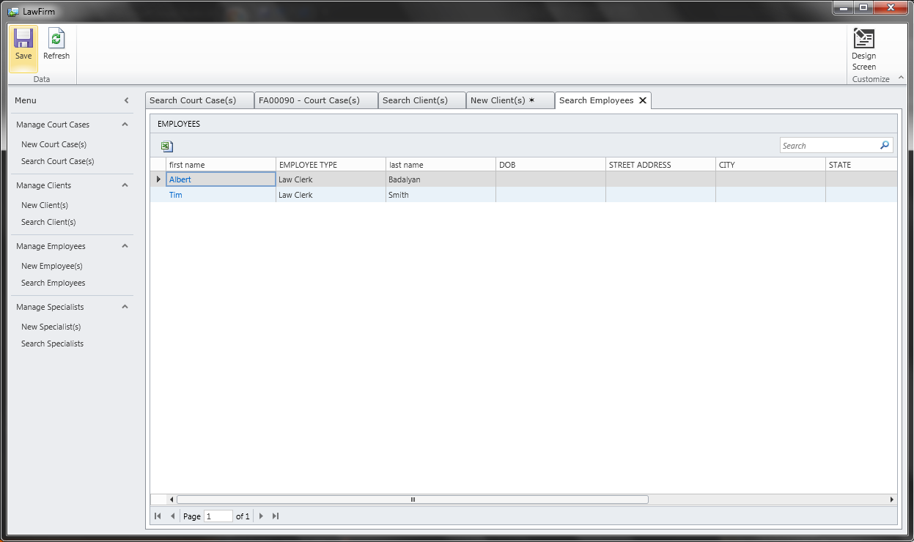

New employee data entry screen:

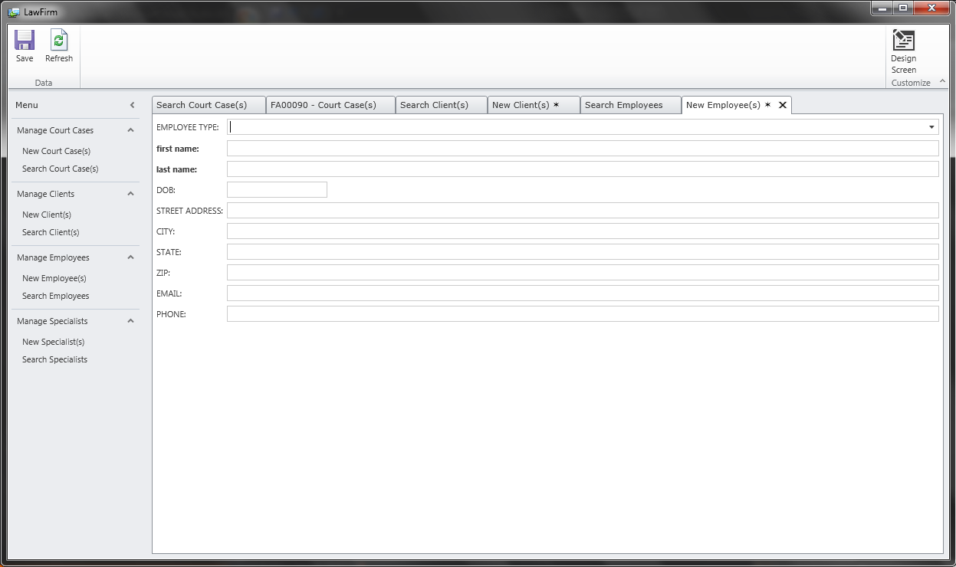

Specialist search screen:

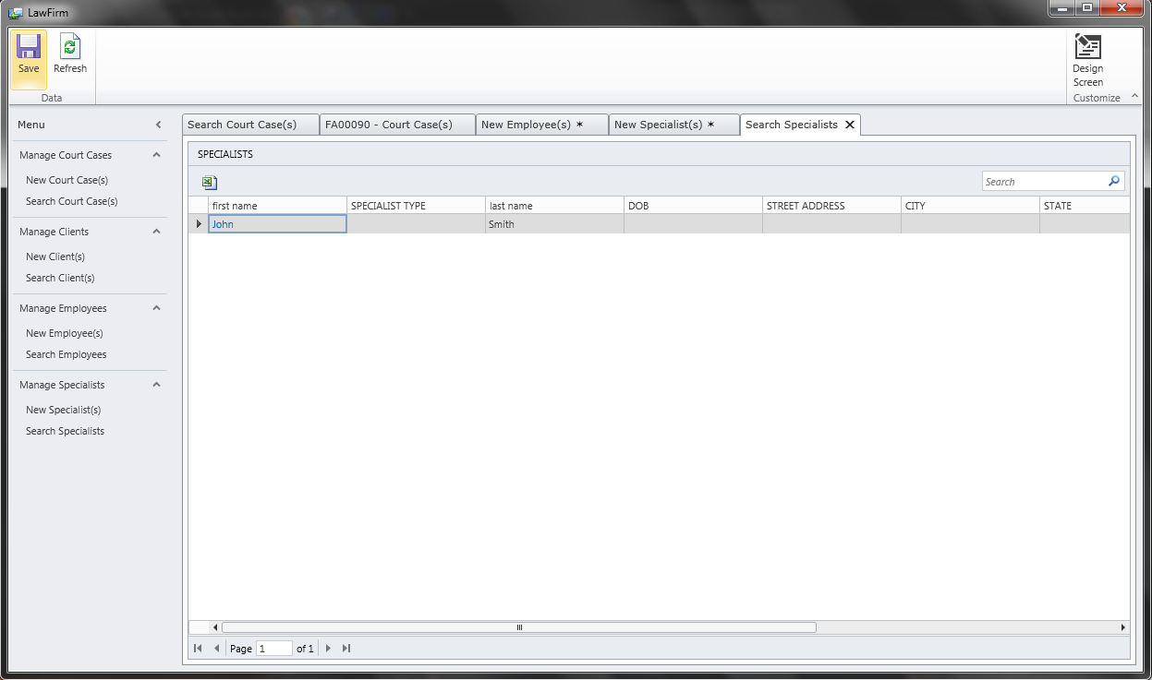

New specialist data entry screen:

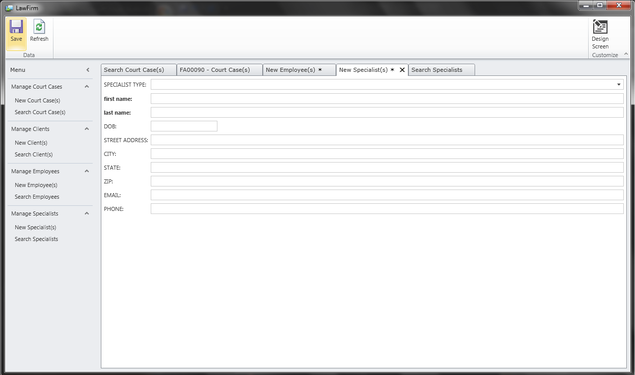

## User Manual

1. Installation
   1. Required Hardware/Software

In order to install DRM application your system must have the minimum requirements.

|  |  |
| --- | --- |
| Operating System | Windows XP, 7 |
| Free Space | 300MB |
| Processor | 1.8ghz or higher |
| Browser | Internet Explorer (Firefox/Chrome not supported but may work) |

While other operating systems may work, some of the functionality of the application may be limited.

* 1. Uninstallation

You click the uninstall button located in the program directory under C:\Program Files\DRM

1. Administration Console
   1. Adding/Deleting User Accounts
      1. Only Admins have the ability to add or delete users. In order to add or delete a user you must open up the “Manage Security” tab. From there select “Users”

From there you select the + sign to add a user. On the right hand side you may change their password by repeating the same password twice.

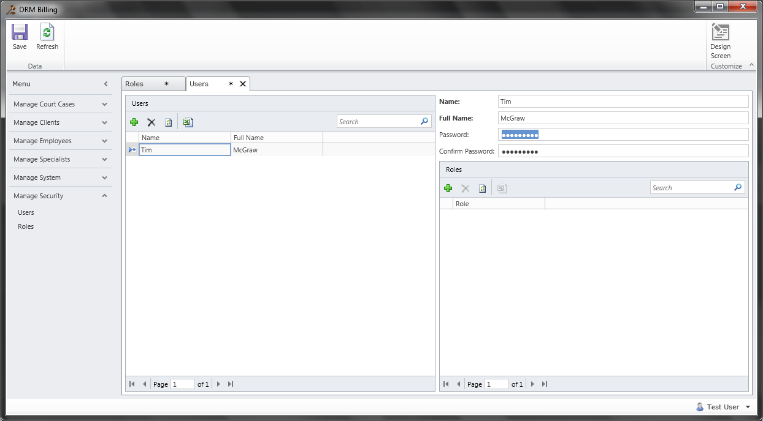

Below that you can assign them roles depending on the level of permission you want to grant to that user.

A way to update or edit the existing roles and their permissions is by opening up Roles under “Manage Security”

From there you can select the Role on the left hand side, and under Permissions on the right pane, you can add or delete certain permissions. Below the Permissions pane you will see current Users assigned to selected Role.

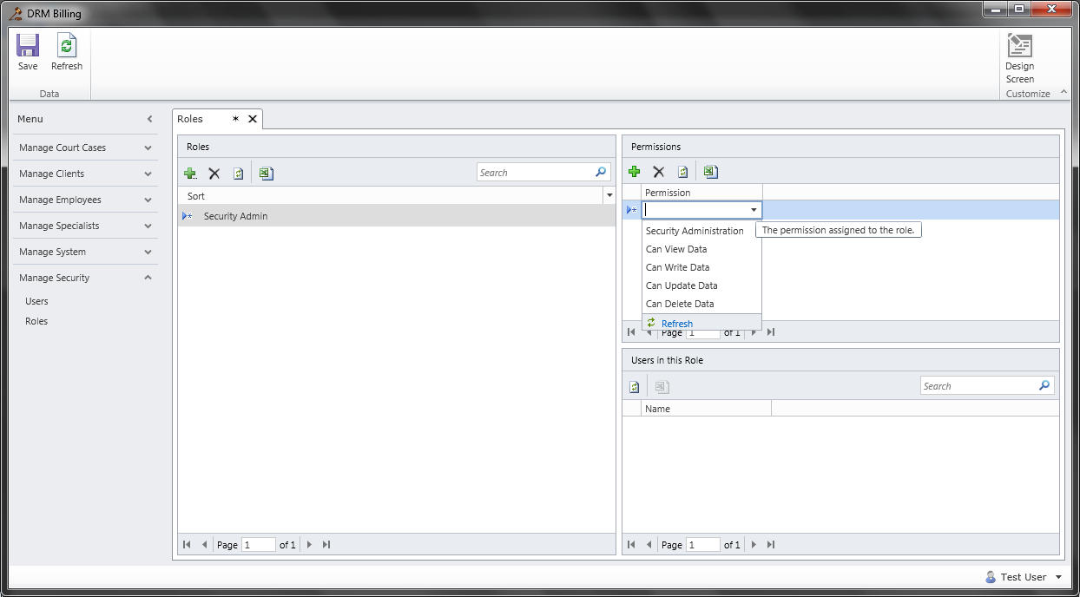

1. Using Application
   1. Creating New Client
      1. In order to create a new client, click on the “Manage Clients” tab on the left hand side of menu pane. Select “New Client”

Fill out the appropriate information and once done click “Save” on the top left corner.

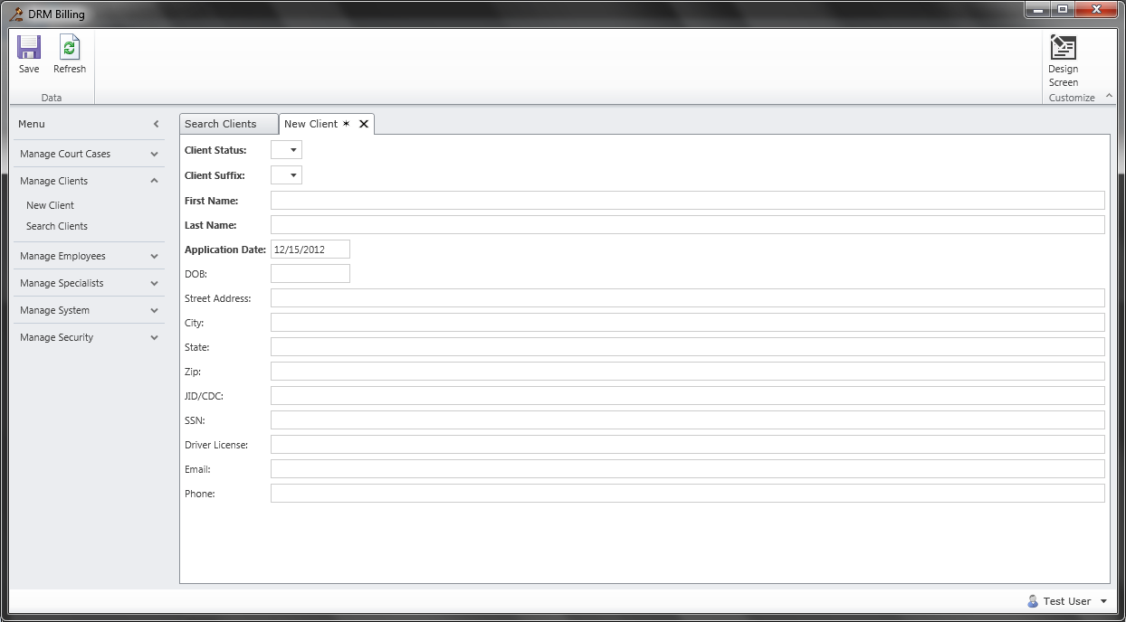

In order to delete a client, click on “Manage Clients” then “Search Clients”.

Next to the clients name click the delete button and then click “Save”.

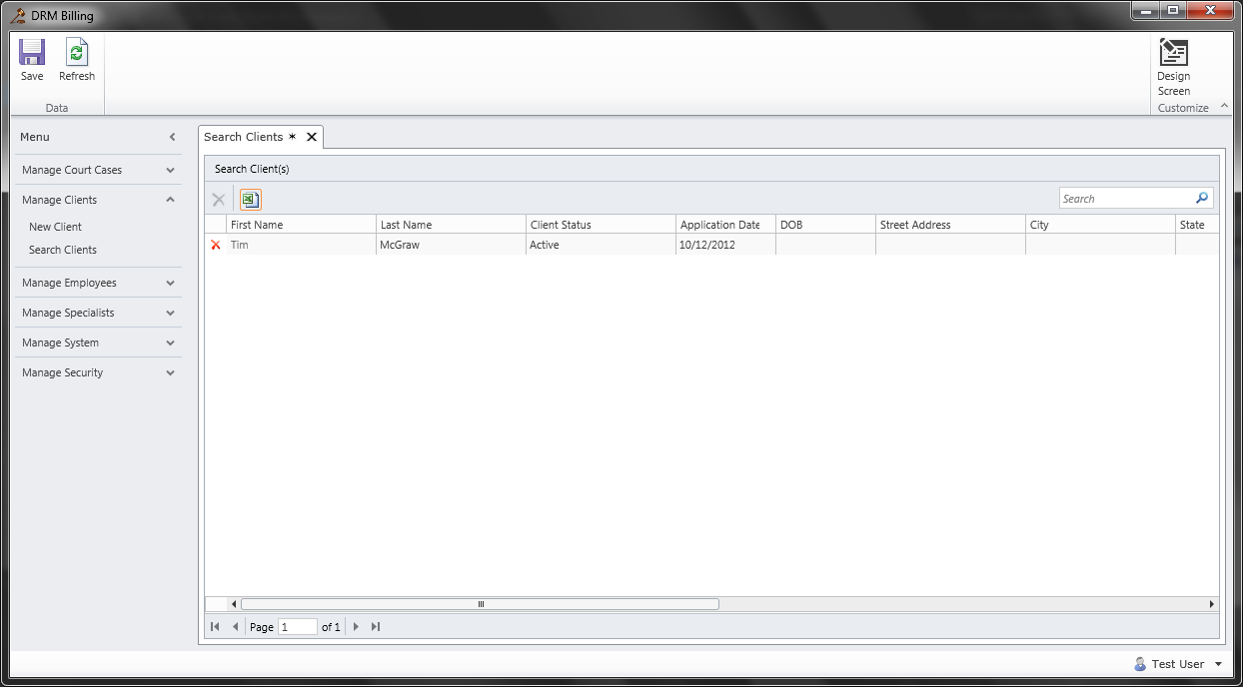

To edit existing clients, click on “Manage Clients” then “Search Clients”.

Edit the existing information then click “Save”.

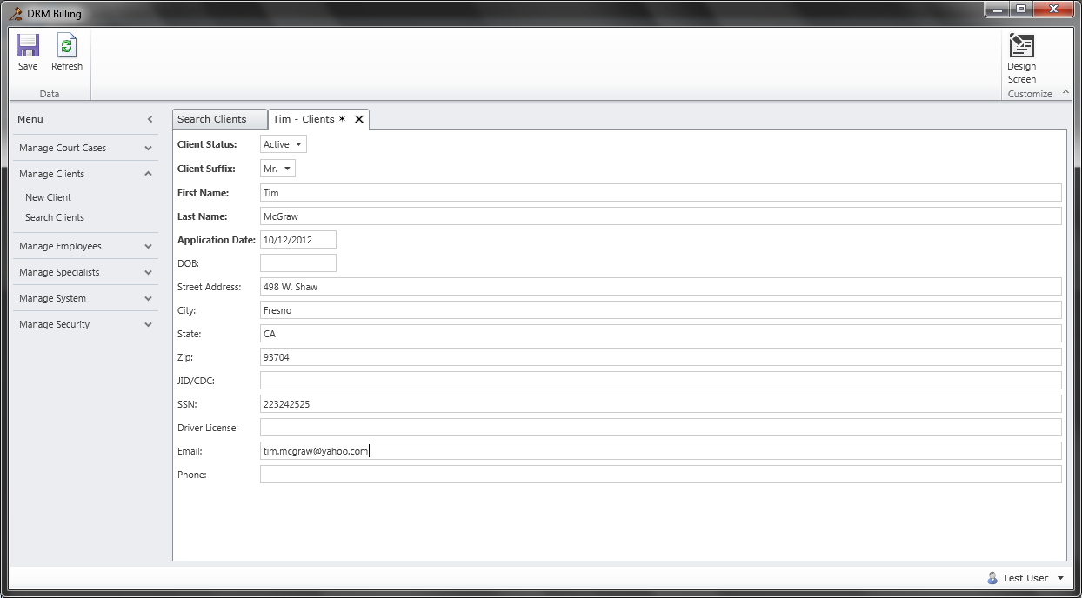

* 1. Creating New Specialist
     1. In order to create a new specialist, click on the “Manage Specialist” tab on the left hand side of menu pane. Select “New Specialist”

Fill out the appropriate information and once done click “Save” on the top left corner.

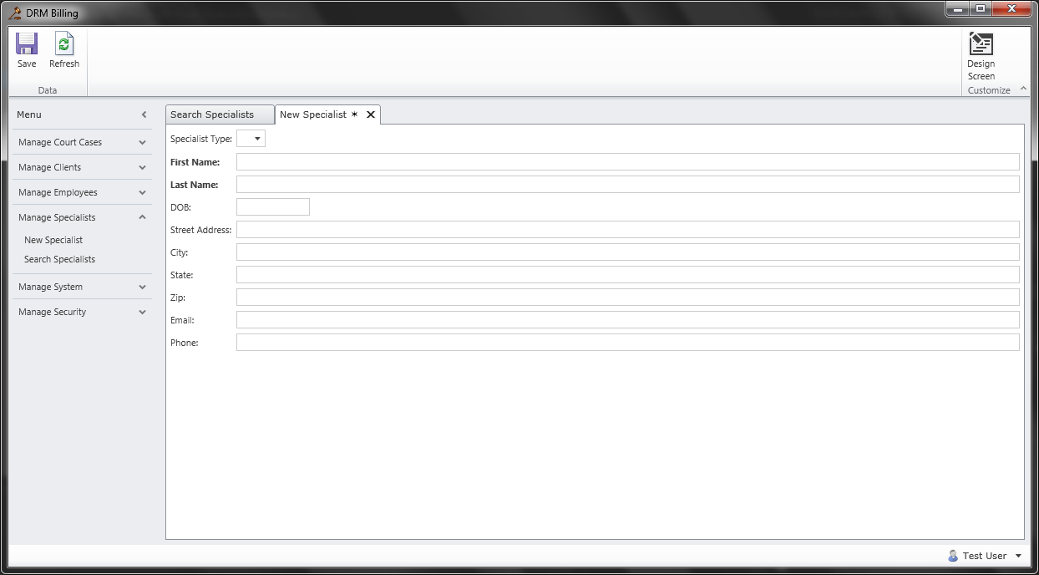

In order to delete a specialist, click on “Manage Specialist” then “Search Specialist”.

Next to the specialist name click the delete button and then click “Save”.

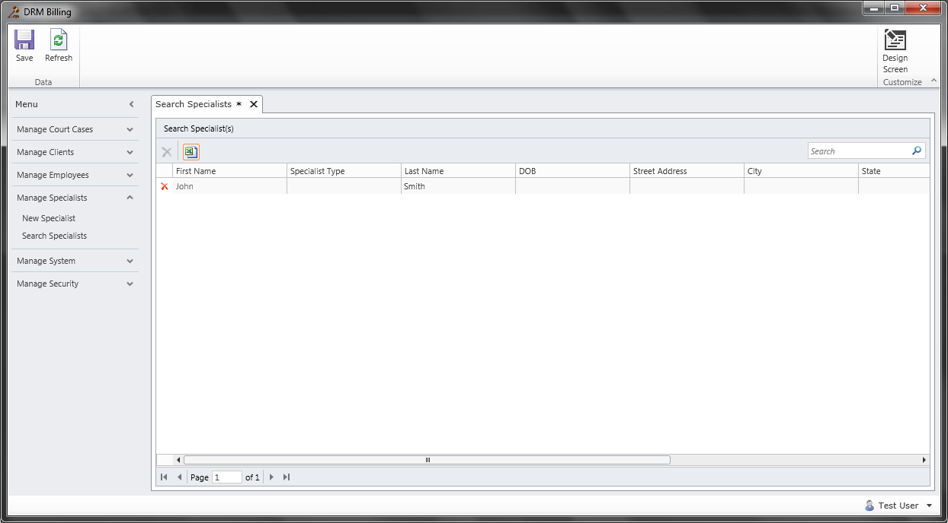

To edit existing specialist, click on “Manage Specialist” then “Search Specialist”.

Edit the existing information then click “Save”.

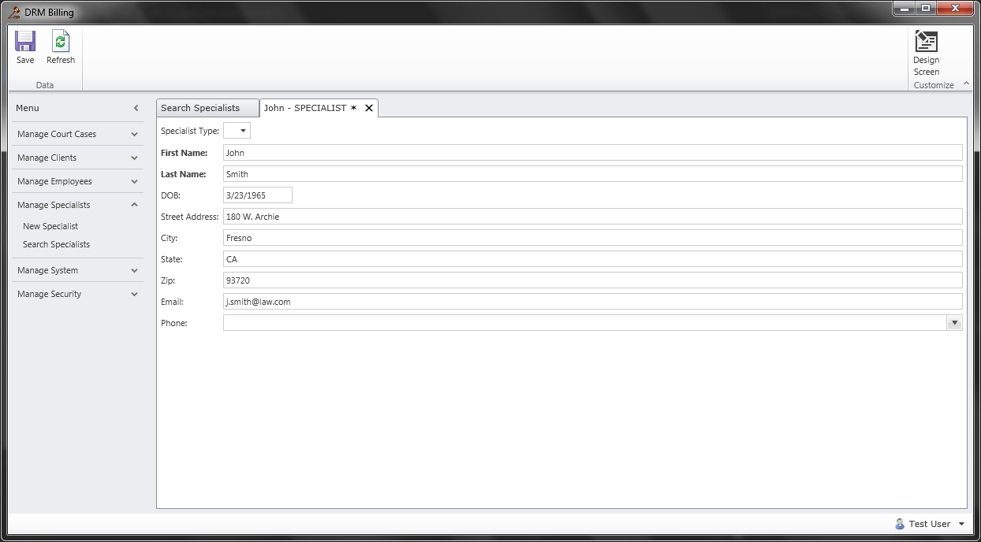

3.2.2 If a user wishes to change his or her password, they must click on the bottom right hand corner where it says their user name and select “Change Password”.

1. Logging/Inputting
   1. In order to input new times for a particular case you begin by opening that case.
      1. Select “Manage Court Cases” and then select either “New Court Case” or “Search Court Cases” depending on if it’s a new case or not.

Once opened on the lower half of the screen, under Employees there will be a + sign for “Add”. This is the screen that will show up.

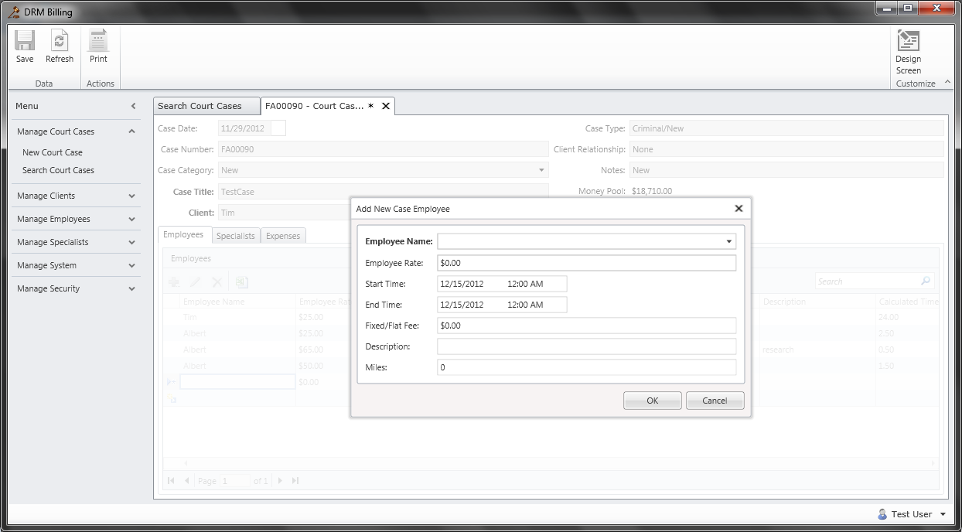

For employees with rates, be sure to enter in the “Employee Rate”. If it is simply a flat fixed rate, be sure to enter in “Fixed/Flat Fee”

Be sure to also include the Start Time and End Time even if it is a Flat Fee. Then hit “OK”

If you wish to edit any existing entries you can edit them in the tables or select an entry and edit it in the previously shown window.

To add new Specialist or Expense be sure to select the appropriate tab and add them accordingly. The following are tables and windows for both.

Specialist

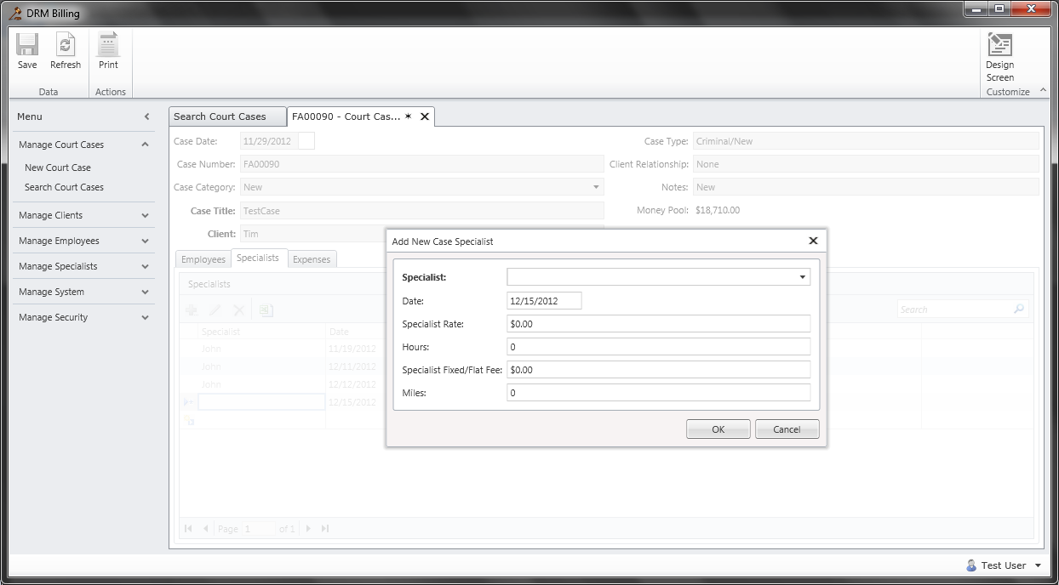

Expense

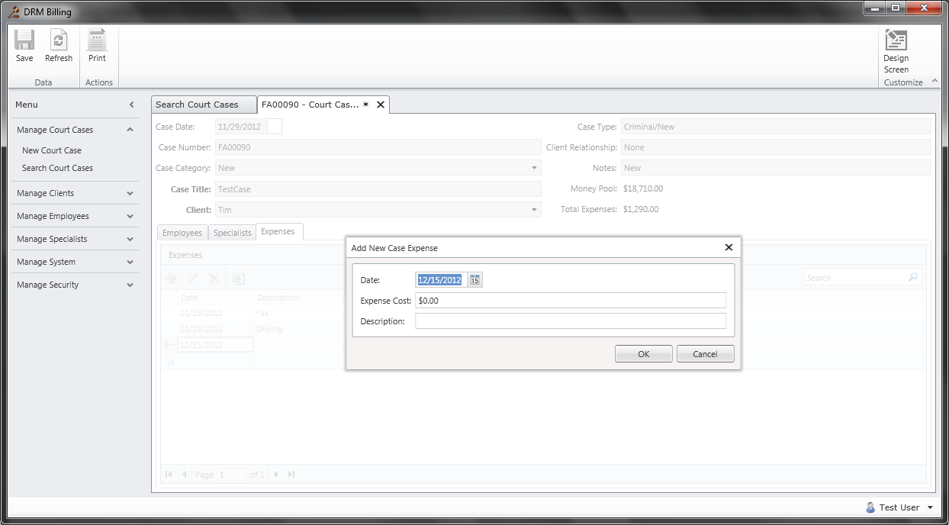

1. Generating PGN-90 E05 Report
   1. In order to generate the PGN-90 E05 Report, the user must have the Court Case that they wish to print the report for Open.

Once opened the user must select the Print Icon in the top left corner. Note this icon will not be visible if a Court Case is not open.

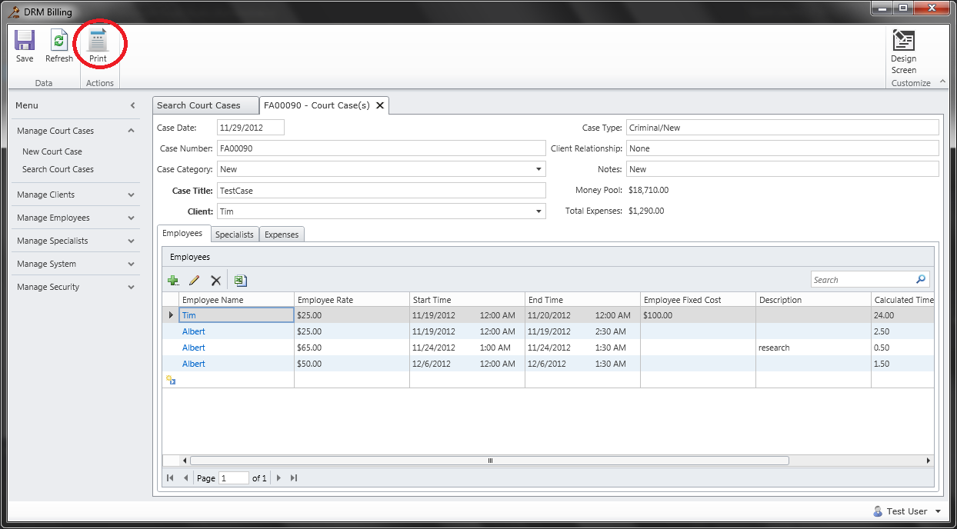

Once opened the user must select the date range for the any employee, specialist or other expenses. One date range will cover all 3 categories. If users do not input a date for an entry, it will not show up in the report.

The report will launch in Internet Explorer. From there it can be printed to either Adobe or printed directly out.